User Manual: General Ledger

| july-20 |

**Document Overview**

**Documentation Goals**

This documentation is intended to provide instruction for ***The General Ledger****.*

**Documentation Disclaimers**

* Teach a user how to utilize the General Ledger Program.
* Provide instructions for creating journal entries for customer transactions, as well as running both end of month and end of year sales reports.

**Table of Contents**

**Overview of Advantzware Specific Keys and Icons** 4

Function Keys 4

Advanced Software Standard Function Keys 5

Program Icons 6

**General Ledger Overview** 7

**Update / Journal Entries [GU]** 8

Enter / Edit Journal Entries [GU1] 8

Overview 8

Add/Update Journal 10

Import Journal Entries from Excel Spreadsheet 11

Print / Post Journal Entries [GU2] 14

Enter / Edit Recurring Journals [GU3] 16

Add/Update Journal 18

Load Journals 22

Import Payroll Entries [GU4] 23

GL Auto Distribution [GU5] 24

**Close Month [GC]** 25

Month End Procedures 25

**Year End [GY]** 28

Overview 28

Year End Procedures 28

**Trial Balance [GT]** 29

**Write Financial Statements [GW]** 31

Financial Statements [GW1] 31

Overview 31

Report Maintenance [GW2] 34

Add/Update Report 36

Add/Update Detail 40

Add Account List 42

Income Statement Ratios [GW3] 43

**Query General Ledger History [GQ]** 45

GL Inquiry 45

GL Run Detail 46

Invoices 47

View Invoice 48

BOL 49

**Reports for General Ledger [GR]** 50

Chart of Accounts [GR1] 50

Current Month Detail [GR2] 52

Transaction Report [GR3] 54

GL Invoice Summary [GR4] 58

GL History [GR5] 60

GL Posting Register [GR6] 62

GL Posting Check [GR7] 64

Reference Date vs. Posting Date [GR8] 66

Journal Entries Report [GR9] 68

**File Maintenance for General Ledger [GF]** 70

Overview 70

Company [GF1] 71

Add/Update Company 73

Add/Update Open Periods 76

GL Accounts [GF2] 77

Add/Update Account 79

Distribute Account 81

Add Distribute Account 81

General Ledger Control [GF3] 82

Update General Ledger Control 83

Banks [GF4] 84

Add Bank 86

Currency Code [GF5] 89

Currency Settings Steps 89

Add/Update Currency 91

Import GL Accounts Budgets [GF6] 92

# **Overview of Advantzware Specific Keys and Icons**

## Function Keys

|  |  |
| --- | --- |
| BRWS | The browser, which is a list of records in this file. This is functionally equivalent to the Find option of our standard package. |
| VIEW | View record provides the ability to ADD, CHANGE, DELETE, and UPDATE an individual record. |
| SORT BY | The selections at the bottom of the browser, which will sort the list alphabetic order. |
|  |  |
| Update | Update the current record. |
| Reset | Reset the current record. |
| Add | Add a record. |
| Copy | This will copy the existing record. |
| Delete | Delete the current record displayed on the screen. |
| Cancel | Cancel the information that was entered. |
| Save | Save the record. |
|  |  |
|  | Takes the user to the first current record. |
|  | Moves backward one record. |
|  | Moves forward one record. |
|  | Takes the user to the last current record. |
|  |  |
| F1 | Miscellaneous Fields |
| F3 | Search |
| F3 | List |
| F4 | Notes |
| F6 | Browse |
| F7 | Viewer |
| F12 | Exit |

## Advanced Software Standard Function Keys

|  |  |
| --- | --- |
| Next | Shows the next sequential record. |
| Prev | Shows the previous record. |
| Add | Add a record. |
| Change | Change the current record displayed on the screen. |
| Delete | Delete the current record displayed on the screen. |
| Find | Find a record by searching by description. |
| “1”, “2” | Number 1 or 2 to go the first or second page of this record. |
| Esc | Escape from the current transaction without updating. |
| Q | Quit from the current transaction without updating. |
| F1 | Save |
| F3 | Help information is available on every data field. Simply place the cursor on a field and press F3 to display documentation regarding this particular field. |
| F3 | To insert additional data in a data field without erasing the information currently displayed. |
| F4 | Notes – General |
| F1 | Field Lookup is available on every data field which is maintained in a separate file. Place the cursor on a field and press ***“F1”*** to search for the code by description or to advance a screen of records by pressing the next key. Place the cursor next to the desired record and press enter to transfer the record to the data entry screen. See ***“Page Up”*** / ***“Page Down”*** keys below as an alternative |
| F7 | Delete |
| F8 | Notes – File Specific |
| Enter | Advances the cursor to the next field |
| Page Up | Will skim forward through each record in a data file in sequential order |
| Page Down | Will skim backward through each record in a data file in sequential order |
|  |  |

## Program Icons

|  |  |  |
| --- | --- | --- |
|  | Job Notes |  |
|  | Customer Attachments | Attach files (such as Word/Excel/Images) for this specific customer order. |
|  | Change Move/Set Column Mode |  |
|  | Print Acknowledgement |  |
|  | Export to Excel |  |
|  | Add |  |
|  | Attachments | Attachments for this Estimate. Will transfer to all future repeat orders for this estimate. |
|  | Notes |  |
|  | Spec Notes | Notes for specific finished goods items. |
|  | Utility Application |  |
|  | Help |  |
|  | UDF Viewer |  |
|  | Commissions |  |
|  | Exit |  |
|  |  |  |
|  |  |  |

# **General Ledger Overview**

The General Ledger, the 'heart' of accounting application, maintains the individual general ledger accounts which provide detailed and cumulative analysis of the effects of accounting transactions. An accounting period (i.e., a month) does not have to be closed before entering transactions for a new period. The current year does not have to be closed before a new year is open. However, you must close last year before the first period of the new year. The general ledger application maintains a separate Transaction File for each period. Additionally, a period may be reopened and closed many times, but only before closing the next month.

The General Ledger Chart of Accounts is created and maintained by the General Ledger Application. Each account contains a 2-year activity history and a 1-year budget.

The General Ledger application provides special management reporting capabilities. All reports (balance sheet and income statements), are prepared from user defined formats. In addition, the report writer can be used to design any summarized G/L report, including 'Source and Use of Working Capital' and 'Change in Cash Position'. Statements can be produced before the accounting period is closed or during the current period. Yearend reports can be run anytime.

The General Ledger comes with a variety of standard reports including: Chart of Accounts, Current Month Detail, Trial Balance, Financial Statements, Journal Transaction Report and GL Invoice Summary.

#### Journal Entries

The general ledger journal entries provide for manually entering transactions that are not automatically created from other modules. A special feature of the Journal Entry function is the ability to reverse the entry in a different period (mostly for accrual-based accounting systems).

#### Month End

The month end procedure closes the current month selected and adds up the activity in all the revenue and expense accounts to get the net income for that month. It then takes this total and stores it in the profit contra’s account history. When yearend is run the system then takes the total stored in the profit contra’s history for all months and places the total in the retained earnings. You must close each month in order and all months must be closed before closing the current year. You may not close period 1 in a new year until all months in a prior year are closed. You must run year end for prior year before closing period 1 of new year.

#### Year End

The yearend procedure closes the current year. When yearend is run the system then takes the total stored in the profit contra’s history for all months and places the total in the retained earnings.

Please Note: You must run year end before closing period 1 of new year.

# **Update / Journal Entries [GU]**

## Enter / Edit Journal Entries [GU1]

### Overview

The general ledger journal entries provide for manually entering transactions that are not automatically created from other modules. To add a journal transaction, press the ***"A"*** (Add) key. Press ***"D”*** to delete or press ***"C"*** to change an existing journal transaction that has not been posted.

The register displays or prints a list of journal transactions prior to posting. Once the register has been printed or viewed on the terminal, you will then be asked if you want to post these journal entries. Enter ***“Y”*** (Yes) if posting is desired at this time or ***“N”*** (No) if it is not.

The general ledger journal entries provide for manually entering transactions that are not automatically created from other modules or to make general ledger adjustments. To add a journal transaction, press the ***"A"*** (Add) key. Press ***"D”*** to delete or press ***"C"*** to change an existing journal transaction that has not been posted.

### Browse Journals

The register displays or prints a list of journal transactions prior to posting. Once the register has been printed or viewed on the terminal, you will then be asked if you want to post these journal entries.

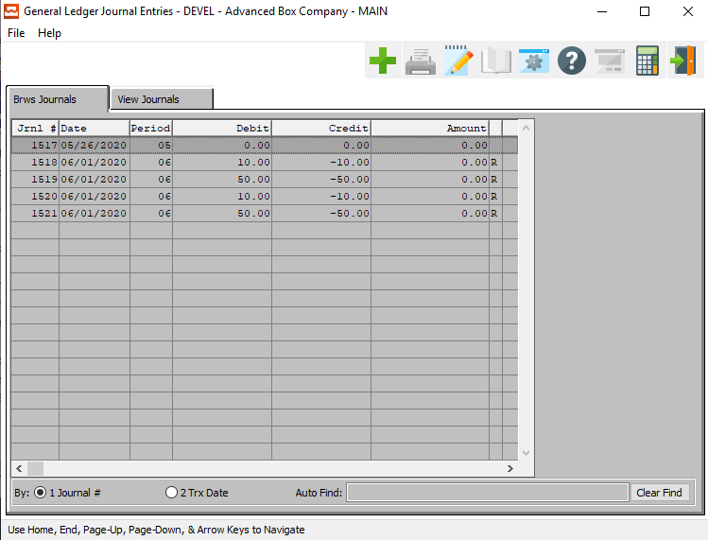

#### ADD

Click the ***“Green + Icon”*** to add a new journal.

### View Journals

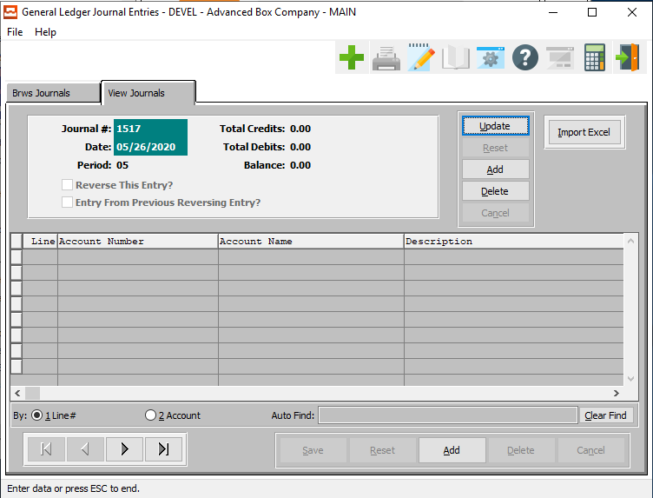

#### UPDATE

To change a journal, simply click the ***“Update***” button at the bottom of the screen.

#### ADD

To add journal, simply click the ***“Green + Icon”*** button at the top of the Journal Entry screen.

Alternatively, click the ***“Add”*** button at the bottom of the screen.

#### DELETE

To delete a selected journal, simply press the ***"D"*** key. Alternatively, click the ***“Delete”*** button at the bottom of the screen.

#### IMPORT EXCEL

Click the ***“Import Excel”*** button to import a journal from an existing excel file.

#### ADD (LINE)

To add an line to the currently selected journal, simply click the ***“Add”*** button at the bottom of the screen.

#### NEXT

Press ***"N"*** (Next) to find next journal to view or modify. Alternatively, press the ***“Right Arrow”*** on the screen.

#### PREVIOUS

Press ***"P"*** (Previous) to find previous journal to view or modify. Alternatively, press the ***“Left Arrow”*** on the screen.

### Add/Update Journal

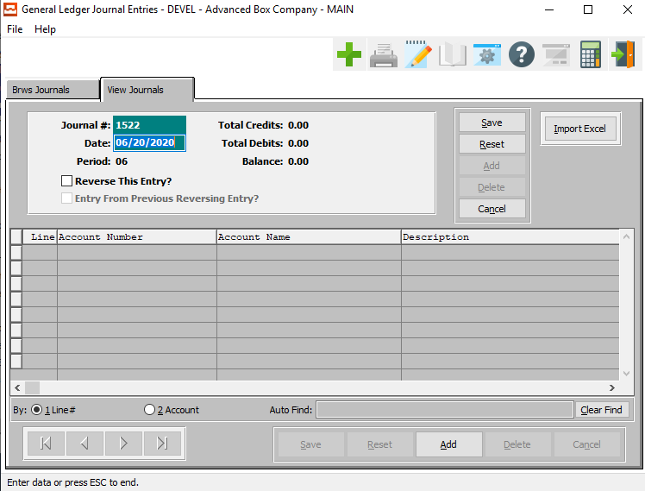

#### SAVE

Click the ***“Save”*** button to save all changes to the current journal.

#### RESET

Click the ***“Reset”*** button to reset all fields to their original state.

#### CANCEL

Click the ***“Cancel”*** button to cancel all changes to the journal without saving.

#### IMPORT EXCEL

Click on the ***“Import Excel”*** button to choose an excel file of a journal to import into the system.

#### ADD (LINE)

Click the ***“Add”*** button to add a new line to the current journal.

#### Total Credits

Enter the credit amount to be posted. The total amount of credits entered must equal the total amount of debits entered. To exit the screen, the balance field at the top of the screen must be zero.

#### Total Debits

Enter the debit amount to be posted. The total amount of debits entered must equal the total amount of credits entered. To exit the screen, the balance field at the top of the screen must be zero.

### Add/Update Journal Field Definitions

#### Journal #

This field defaults to next available number or can be changed by user. When pressing ***“Enter”*** on this field the screen prompts you to enter a transaction date. This is the transaction date, not the date used for posting. The posting date is the date used when running the register. You will then come to the line item section of the screen above.

#### Date

Enter the transaction date. This field defaults to the system date. This number comes from the General Ledger control file and may be modified within the control file if needed. The period cannot be changed and is the period relative to the transaction date as defined in the company file's open periods file.

#### Reverse this Entry? – Toggle Box

To reverse the journal entry, make sure that the Reverse this Entry toggle box is checked.

### Import Journal Entries from Excel Spreadsheet

To Start, the journal entry must be set up in excel as below. Row 1 and 2 are just explaining what fields and in what order the journal has to be set up.

The first line of the journal is the information in the header of the journal, (posting date and whether the journal is a reversing journal). Enter ***“Yes”*** for recurring or ***“No”*** if not a recurring journal. You must have an H in the second column to identify this as the header line. The header line must appear before the line items or “T” lines.

The following lines under that are for the actual journal entries. First column is your unique identifying number, the second column is to identify that it is the line item, “T” line, the 3rd column is the general ledger account number, the 4th column is for the Description for the line and the final column is for the amount or trailer amount. Those first 2 rows must be deleted after setting up excel journal entry, as shown on second screen below.

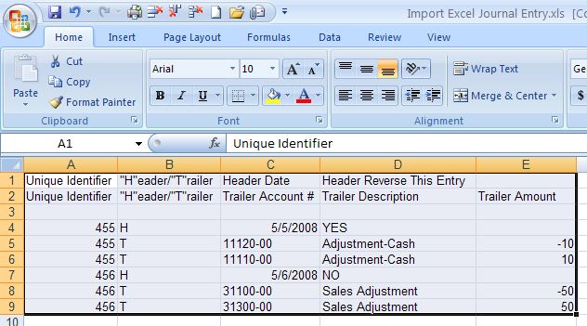

Above screen must be shown as below without the header names when finished and before importing

into Advanced Software as shown below.

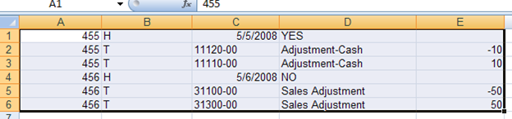

To begin importing a journal entry from an excel spreadsheet, you must open GU1 (Enter/Edit Journal Entries) on the General Ledger menu. Click on the “***Import Excel”*** button on the journal entry screen shown above. Type in the location of the excel file to import or browse to find.

### Add Line

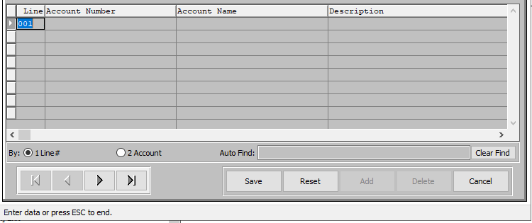

#### SAVE

Click the ***“Save”*** button to save all changes to the current journal line.

#### RESET

Click the ***“Reset”*** button to reset all fields to their original state.

#### CANCEL

Click the ***“Cancel”*** button to cancel all changes to the journal line without saving.

#### NEXT

Press ***"N"*** (Next) to find next line to view or modify. Alternatively, press the ***“Right Arrow”*** on the screen.

#### PREVIOUS

Press ***"P"*** (Previous) to find previous line to view or modify. Alternatively, press the ***“Left Arrow”*** on the screen.

### Add Line Field Definitions

#### Line Number

The Line number designates the order in which the report will print. Line numbers do not have to be consecutive, however they have to be unique within the report definition.

We strongly suggest that you leave room between line numbers so that additional lines may be added if required later. The system automatically defaults the advances the numbers by 10. We start at 100 and advanced by ten to 110 ,120, 130, etc. If you think more room is needed between lines, then this number is modifiable.

#### Account Number

Press ***“Enter”*** and the default from the Control File will transfer. To find an account number, enter a specific account number, press the ***“Page Up”*** / ***“Page Down”*** keys to retrieve the next/previous account number or the ***“F1”*** key to display a list of numbers. Prior to pressing the ***“F1”*** key, a partial account number may be entered to start the search. There can be up to five levels per account number with up to 9 digits per level. There is a maximum of twenty-five characters per account number.

The ***“F1”*** key displays the account numbers, along with a black bar at the bottom. The “***Up-Arrow”*** key moves the cursor to the previous account number, the ***“Down-Arrow”*** key moves the cursor down to the next account number; the home key toggles between the first and last account numbers, the ***“Page Up”*** / ***“Page Down”*** keys move the cursor up or down one page of account numbers respectfully, the enter key selects the current account from the pop-up as the correct account number, and the escape key return to the account field without changing or selecting the account number. When the account number is selected, the account description is displayed.

#### Account Name

The name for the current account. This section will automatically fill as soon as the user enters or chooses a valid account number.

#### Description

Enter the description for the current transaction. This description will print on the edit/posting report and also be used in the transaction file. Pressing any key other than the enter key will wipe out the description on the current line. Press the ***"Enter"*** key to move the next field.

#### Amount

Enter the dollar amount for this current entry.

## Print / Post Journal Entries [GU2]

### Selection Parameters

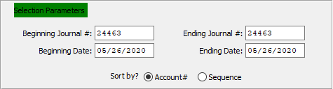

#### Beginning Journal # / Ending Journal #

Enter the beginning and ending journal number to run the report for.

#### Beginning Date / Ending Date

Enter the beginning and ending journal entry date to run the report for.

#### Sort By? (Choice)

To choose the preferred sort method of Account Number vs. Sequence Number, please make sure the desired option choice bubble is toggled.

### Available and Selected Columns

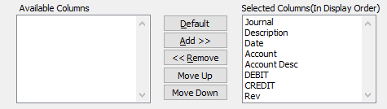

#### Available Columns

The user may choose which columns they wish to have on the report printout. As the user selects their choices, they will appear on the ‘*Selected Columns’* list.

#### Selected Columns (In Display Order)

The columns that the user has chosen from the ‘*Available Columns’* list. The order that these columns are displayed in here is the order in which they will print on the report.

#### Default

Click the ***“Default****”* button to sort the ‘*Selected Columns’* list by the default system parameters.

#### Add >>

Click on the selected item from the ‘*Available Columns’* list to highlight it, then click the ***“Add”*** button to add the selected column to the ‘*Selected Columns’* list.

#### << Remove

Click on the selected item from the ‘*Selected Columns’* list to highlight it, then click the ***“Remove”*** button to remove the selected column to the ‘*Selected Columns’* list.

#### Move Up

Within the ‘*Selected Columns’* list, the user may choose the order they wish the selected columns to print in. In order to change the order of the columns, the user can click on a selection to highlight it. By then clicking the ***“Move Up***” button, the user can change its position on the report.

#### Move Down

Within the ‘*Selected Columns’* list, the user may choose the order they wish the selected columns to print in. In order to change the order of the columns, the user can click on a selection to highlight it. By then clicking the ***“Move Down***” button, the user can change its position on the report.

### Output Destination

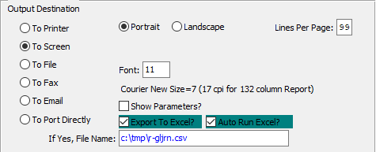

#### Destination Choice

To choose the destination where the document should be printed, please make sure that desired output destination choice bubble is toggled.

#### Layout Choice

To choose the preferred layout of Landscape vs. Portrait, please make sure the desired option choice bubbled is toggled.

#### Lines Per Page

Lines per page on the report when printing.

#### Font

Enter the font number to use with this report (Font 11 is default).

#### Show Parameters? – Toggle Box

To show parameters, make sure that the toggle box is ‘ticked’ with a checkmark.

#### Export to Excel? – Toggle Box

To export the printed file to an excel document, make sure that the Export to Excel toggle box is checked.

#### Auto Run Excel? – Toggle Box

To automatically open the new excel document, make sure that the Auto Run Excel toggle box is checked.

#### If Yes, File Name

If exporting the file to Excel, enter the desired file name.

## Enter / Edit Recurring Journals [GU3]

### Browse Journals

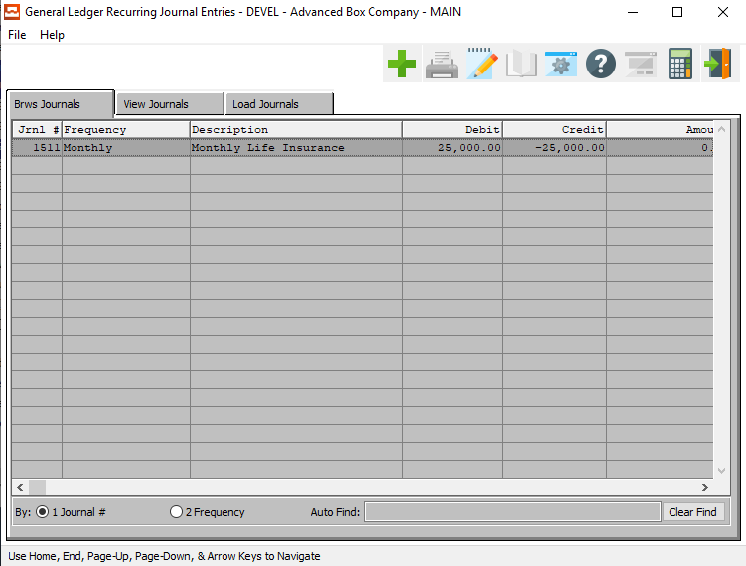

#### ADD

Click the ***“Green + Icon”*** to add a new Journal.

### View Journals

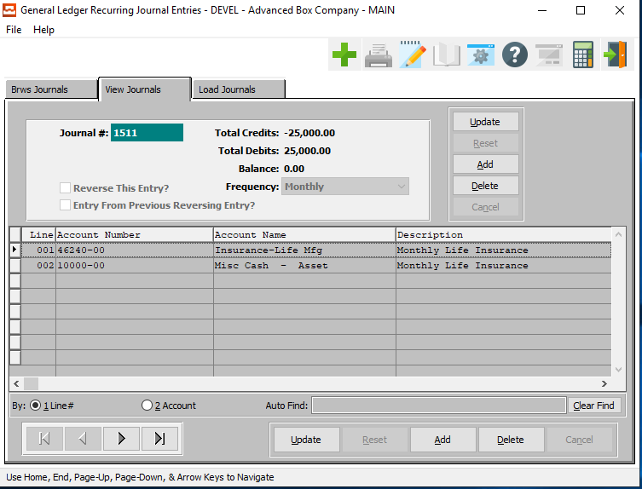

#### ADD

To add a journal, simply click the ***“Green + Icon”*** button at the top of the Recurring Journal screen.

Alternatively, click the ***“Add”*** button to the side of the journal section of the screen.

#### DELETE

To delete a journal, simply click the ***“Delete”*** button to the side of the journal section of the screen.

#### UPDATE (LINE)

To change an line of the journal, simply click the ***“Update***” button at the bottom of the screen.

#### ADD (LINE)

Click the ***“Add”*** button at the bottom of the screen to add a new line to the current journal.

#### DELETE (LINE)

To delete a line, simply press the ***"D"*** key. Alternatively, click the ***“Delete”*** button at the bottom of the screen.

#### NEXT

Press ***"N"*** (Next) to find next journal to view or modify. Alternatively, press the ***“Right Arrow”*** on the screen.

#### PREVIOUS

Press ***"P"*** (Previous) to find previous journal to view or modify. Alternatively, press the ***“Left Arrow”*** on the screen.

### Add/Update Journal

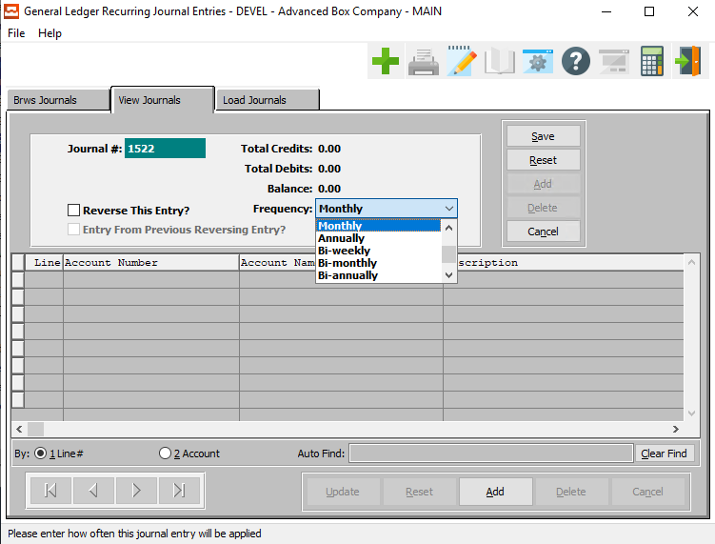

#### SAVE

Click the ***“Save”*** button to save all changes to the current journal.

#### RESET

Click the ***“Reset”*** button to reset all fields to their original state.

#### CANCEL

Click the ***“Cancel”*** button to cancel all changes to the journal without saving.

#### ADD (LINE)

Click the ***“Add”*** button to add a new journal.

### Add/Update Journal Field Definitions

#### Journal #

This field defaults to next available number or can be changed by user. When pressing ***“Enter”*** on this field the screen prompts you to enter a transaction date. This is the transaction date, not the date used for posting. The posting date is the date used when running the register. You will then come to the line item section of the screen above.

#### Reverse this Entry? – Toggle Box

To reverse the journal entry, make sure that the Reverse this Entry toggle box is checked.

#### Frequency

The user may choose how often to run this recurring journal entry from a drop-down list of options.

Valid options are as follows:

|  |  |  |  |
| --- | --- | --- | --- |
| Daily | Intermittently | Weekly | Bi-Weekly |
| Monthly | Bi-Monthly | Annually | Bi-Annually |

### Add/Update Line

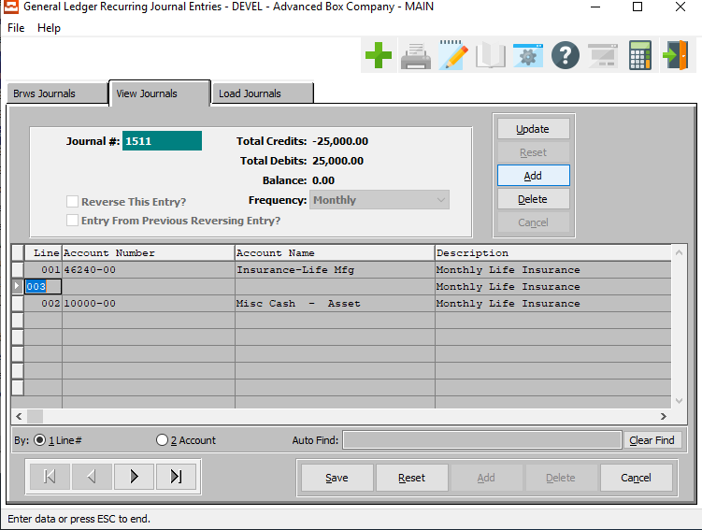

#### UPDATE

To change an XXX, simply click the ***“Update***” button at the bottom of the screen.

#### ADD

To add an a new journal, simply click the ***“Green + Icon”*** button at the top of the Recurring Journal Entry screen.

Alternatively, click the ***“Add”*** button at the bottom of the screen.

#### DELETE

To delete a journal, simply press the ***"D"*** key. Alternatively, click the ***“Delete”*** button at the bottom of the screen.

#### SAVE

Click the ***“Save”*** button to save all changes to the current journal.

#### RESET

Click the ***“Reset”*** button to reset all fields to their original state.

#### CANCEL

Click the ***“Cancel”*** button to cancel all changes to the journal without saving.

#### NEXT

Press ***"N"*** (Next) to find next journal to view or modify. Alternatively, press the ***“Right Arrow”*** on the screen.

#### PREVIOUS

Press ***"P"*** (Previous) to find previous journal to view or modify. Alternatively, press the ***“Left Arrow”*** on the screen.

### Add/Update Line Field Definitions

#### Line Number

The Line number designates the order in which the report will print. Line numbers do not have to be consecutive, however they have to be unique within the report definition.

We strongly suggest that you leave room between line numbers so that additional lines may be added if required later. The system automatically defaults the advances the numbers by 10. We start at 100 and advanced by ten to 110 ,120, 130, etc. If you think more room is needed between lines, then this number is modifiable.

#### Account Name

The name for the current account. This section will automatically fill as soon as the user enters or chooses a valid account number.

#### Description

Enter the description for the current transaction. This description will print on the edit/posting report and also be used in the transaction file. Pressing any key other than the enter key will wipe out the description on the current line. Press the ***"Enter"*** key to move the next field.

#### Amount

Enter the dollar amount for this current entry.

### Load Journals

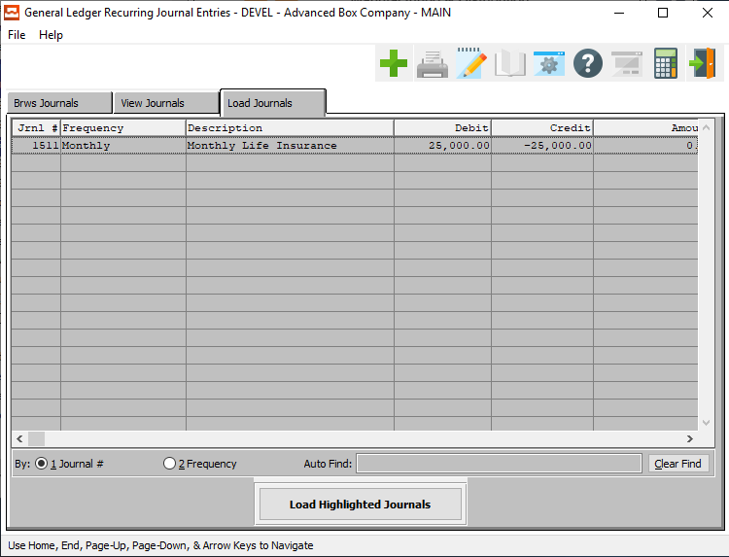

#### LOAD HIGHLIGHTED JOURNALS

To load highlighted journals, click on a journal entry to highlight it. To select multiple journal entries, press the ***“Control”*** button on the keyboard and click on multiple rows.

Clicking the ***“Load Highlighted Journals”*** button will select all highlighted recurring journal entries for posting.



The user will then be prompted to enter their chosen posting date for all of the selected entries. This date will automatically default to the current system date, but may be modified by the user.

## Import Payroll Entries [GU4]

### Selection Parameters

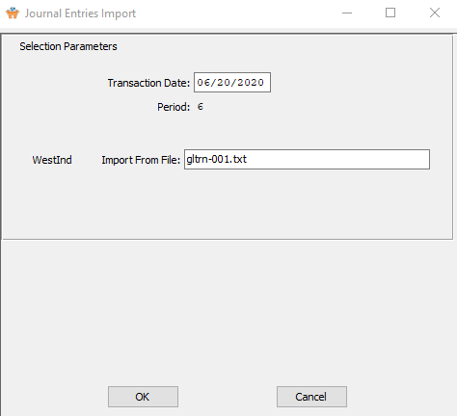

#### Transaction Date

Enter the transaction date for the importation of payroll entries.

#### Period

This field is equal to the period associated with the transaction date.

#### Import from File

Enter the import file name in this field. Press ***“F1”*** to look-up drive letter and location of file.

## GL Auto Distribution [GU5]

### Selection Parameters

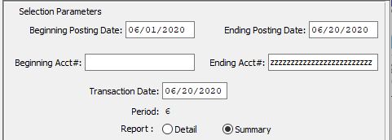

#### Beginning Posting Date / Ending Posting Date

Enter the beginning and ending posting date to run the report for.

#### Beginning Account # / Ending Account #

Enter the beginning and ending account number to run the report for.

#### Transaction Date

Enter the transaction date for the automatic distribution.

#### Period

This field is equal to the period associated with the transaction date.

#### Report (Choice)

To choose the preferred report method of Detailed Report vs. Summary Report, please make sure the desired option choice bubble is toggled.

### Output Destination

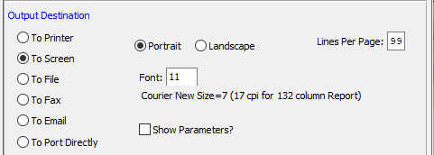

#### Destination Choice

To choose the destination where the document should be printed, please make sure that desired output destination choice bubble is toggled.

#### Layout Choice

To choose the preferred layout of Landscape vs. Portrait, please make sure the desired option choice bubbled is toggled.

#### Show Parameters? – Toggle Box

To show parameters, make sure that the toggle box is ‘ticked’ with a checkmark.

# **Close Month [GC]**

The month end procedure closes the current month selected and adds up the activity in all the revenue and expense accounts to get the net income for that month. It then takes this total and stores it in the profit contra’s account history. When yearend is run the system then takes the total stored in the profit contra’s history for all months and places the total in the retained earnings.

## Month End Procedures

The following checklist is provided as an example of how you might use the accounting system to perform monthly/period tasks.

#### 1 – Run a Backup of All Data Files

Make sure all prior months are closed. If you are closing period 1 of new year make sure all months of prior year are closed as well as the prior year.

#### 2 – Accounts Receivable

A. Enter any final A/R Invoices, using *A/R Invoice Processing*

B. Print an A/R Aging Report, using *A/R Reports,* and reconcile accounts.

C. Print customer statements, using *A/R Reports*

#### 3 – Accounts Payable

A. Enter any final A/P Vendor Invoices, using *A/P Vendor Invoice Processing*

B. Print an A/P Aging Report, using *A/P Reports,* and reconcile accounts.

C. Print tax reporting, using *A/P Reports*

D. Reconcile your checkbook(s), using *A/P Check Reconciliation*

#### 4 – Sales Analysis

A. Print Any or All Sales Analysis reports, using *Sales Analysis*

#### 5 – Cost Estimating, Order Processing, Raw Materials, Finished Goods, Production Control, Job Costing, and Purchasing

A. Print any reports needed.

#### 6 – General Ledger

A. Make any final journal entries or month end adjustments, using G/L *Journal Entries*.

B. Print a Trial Balance, using *G/L Trial Balance*

C. Print Financial Statements, using *G/L Financial Statements*

D. Close the current month, using *G/L Month End*

## Selection Parameters

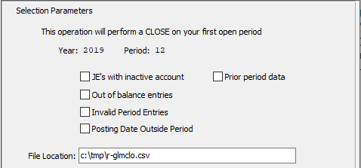

#### Journal Entry’s with Inactive Account – Toggle Box

To close all journal entries that have an inactive account, make sure that this toggle box is checked.

#### Prior Period Data – Toggle Box

To close any prior period data that may still be open, make sure that the Prior Period Data toggle box is checked.

#### Out of Balance Entries – Toggle Box

To close any files that are out of balance, make sure that the Out of Balance Entries toggle box is checked.

#### Invalid Period Entries – Toggle Box

To close entries with an invalid period number, make sure that the Invalid Period Entries toggle box is checked.

#### Posting Date Outside Period – Toggle Box

To close any journal entries with a posting date outside of the current period, make sure that this toggle box is checked.

#### File Location

The user may enter the file path location for the destination in which they choose to have the end-of-month report saved to. Alternatively, the user may press the ***“F1”*** button to choose their file path using the Windows Explorer window.

## Output Destination

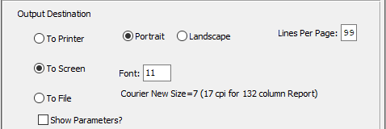

#### Destination Choice

To choose the destination where the document should be printed, please make sure that desired output destination choice bubble is toggled.

#### Layout Choice

To choose the preferred layout of Landscape vs. Portrait, please make sure the desired option choice bubbled is toggled.

#### Lines Per Page

Lines per page on the report when printing.

#### Font

Enter the font number to use with this report (Font 11 is default).

#### Show Parameters? – Toggle Box

To show parameters, make sure that the toggle box is ‘ticked’ with a checkmark.

# **Year End [GY]**

## Overview

Please Note: Before closing a year, it is *Strongly Recommended* that you make a backup of all data files. ***This is very important.***

Please Note: All prior months must be closed before closing the year.

The yearend procedure will zero out all profit and loss accounts and transfer the amount saved in the profit contra account’s history to the retained earnings (or the net income for the year).

#### Which Year

(4) numeric digits. Backup System First!! Enter the year to close. After entering the year, the screen will display the above message reminding you that all the current balances will transfer to previous year and reminding you to make sure all required year end reports are run before.

You will then be prompted to Send the output to the printer. Enter ***“Y”*** (Yes) or ***“N”*** (No) at this time. The report will print. At this time check to make sure all balances are correct.

## Year End Procedures

The following checklist is provided as an example of how you might use the accounting system to perform monthly/period tasks.

#### 1 – Run a Backup of All Data Files

Make sure all prior months are closed for the year.

#### 2 – Accounts Receivable

A. Enter any final A/R Invoices, using *A/R Invoice Processing*

B. Print an A/R Aging Report, using *A/R Reports,* and reconcile accounts.

C. Print customer statements, using *A/R Reports*

#### 3 – Accounts Payable

A. Enter any final A/P Vendor Invoices, using *A/P Vendor Invoice Processing*

B. Print an A/P Aging Report, using *A/P Reports,* and reconcile accounts.

C. Print tax reporting, using *A/P Reports*

D. Reconcile your checkbook(s), using *A/P Check Reconciliation*

#### 4 – Sales Analysis

A. Print Any or All Sales Analysis reports, using *Sales Analysis*

#### 5 – Cost Estimating, Order Processing, Raw Materials, Finished Goods, Production Control, Job Costing, and Purchasing

A. Print any reports needed.

#### 6 – General Ledger

A. Make any final journal entries or yearend adjustments, using G/L *Journal Entries*.

B. Print a Trial Balance, using *G/L Trial Balance*

C. Print Financial Statements, using *G/L Financial Statements*

D. Close the current year, using *G/L Year End*

# **Trial Balance [GT]**

The purpose of the trial balance report is to present the period to date and current year balances of all the general ledger accounts. This will allow an accountants worksheet to be created whenever requested to be printed. The total balance of this report should always be zero.

## Selection Parameters

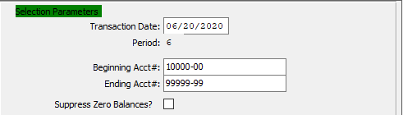

#### Transaction Date

Enter transaction date. The system will print the Trial Balance for the period which is associated with the entered transaction date.

#### Period

This system displays the period associated with the transaction date.

#### Beginning Account # / Ending Account #

Enter the beginning and the ending account number needed or press enter on both fields to default to all account numbers.

#### Suppress Zero Balances? – Toggle Box

This option allows the user to print a trial balance without printing the account numbers that have no activity or zero balances for the period selected. If you want all account number to print regardless of their balance, leave this toggle box unchecked.

## Sort Options

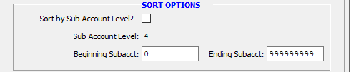

#### Sort by Subaccount Level? – Toggle Box

To sort the balance report by the subaccount levels., make sure that this toggle box is checked.

#### Subaccount Level

Enter the General Ledger Account level used as your sub account. Press enter to default to all subaccount levels.

#### Beginning Subaccount / Ending Subaccount

Enter the beginning and ending Subaccount, if applicable, or press ***“Enter”*** to default to 0. Sub accounts can be defined based upon any level of the account number.

## Output Destination

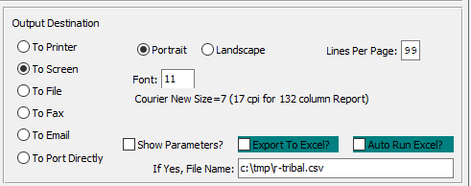

#### Destination Choice

To choose the destination where the document should be printed, please make sure that desired output destination choice bubble is toggled.

#### Layout Choice

To choose the preferred layout of Landscape vs. Portrait, please make sure the desired option choice bubbled is toggled.

#### Lines Per Page

Lines per page on the report when printing.

#### Font

Enter the font number to use with this report (Font 11 is default).

#### Show Parameters? – Toggle Box

To show parameters, make sure that the toggle box is ‘ticked’ with a checkmark.

#### Export to Excel? – Toggle Box

To export the printed file to an excel document, make sure that the Export to Excel toggle box is checked.

#### Auto Run Excel? – Toggle Box

To automatically open the new excel document, make sure that the Auto Run Excel toggle box is checked.

#### If Yes, File Name

If exporting the file to Excel, enter the desired file name.

# **Write Financial Statements [GW]**

## Financial Statements [GW1]

### Overview

Any financial statement may be printed once created with the report writer program. The General Ledger (G/L) Report Writer is a user definable report writer for producing Profit & Loss statements, Balance Sheets, and any other report created via the General Ledger Report Writer. The information to produce the reports is based upon the G/L Account and the G/L Transaction Files.

The G/L account file contains the net balance of the debits and credits for each account for each month for the last two fiscal years as well as monthly budgets for the current fiscal year. The G/L account file is updated when month-end processing is performed. The G/L transaction file contains all G/L transactions that have accrued since the last month-end processing.

The G/L Report Maintenance program is comprised a report heading section and a detail section for selecting the general ledger account numbers. The report writer program also includes a report copy program to duplicate the financial report to speed creation of a new report.

### Selection Parameters

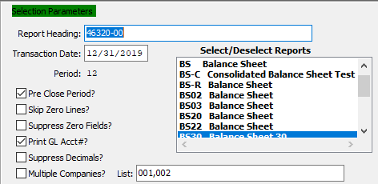

#### Report Heading

Enter the report code or press the ***“F1”*** Function Key to search for a Report Code. Any existing report such as a Balance Sheet or Profit and Loss Statement may be run from this program. Statement may be up to nine columns per report including Current period, Current Year-To-Date, Last-year this period, Last-Year Year-to-date, and Variances. Variance is defined as the difference between Current year-to-date minus last-year year-to-date.

#### Transaction Date

The system will calculate the financial report based upon the period associated with this date. The report will include totals from the G/L Accounts File, and (optionally) the current G/L transactions if the Pre-Closed Journal Flag is set to *‘Yes’*).

#### Period

System assigns the period to the accounting period associated with the Date entered.

#### Pre-Close Period? – Toggle Box

If the period chosen has not been closed as of yet, make sure that this toggle box is checked. If this toggle box is left unchecked, then the report will only print transactions of the prior closed month or period.

#### Skip Zero Lines? – Toggle Box

To skip lines where the amount is equal to zero, make sure that the Skip Zero Lines toggle box is checked.

#### Suppress Zero Fields? – Toggle Box

To suppress entries in which any of the fields are blank, make sure that the Suppress Zero Fields toggle box is checked.

#### Print GL Account #? – Toggle Box

To print the general ledger account number on the report, make sure that this toggle box is checked.

#### Suppress Decimals? – Toggle Box

To suppress decimal number from the report, make sure that the Suppress Decimals toggle box is checked.

#### Multiple Companies? – Toggle Box

In order to select multiple companies for the report, make sure that the Multiple Companies toggle box is checked.

#### List (Companies)

The user may enter multiple company codes in this list (each separated by a comma), to print financial statement reports for each chosen company.

#### Select/Deselect Reports

The user may select which reports they wish to include in the current Financial Statement report. To select multiple reports, press the ***“Control”*** button while clicking the desired reports within the available report list. Selected reports will be highlighted, and only highlighted reports will be included in the Financial Statement report.

To deselect reports, press the ***“Control”*** button while clicking already-highlighted selections.

### Sort Options

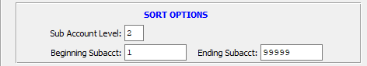

#### Sub Account Level

To choose a specific subaccount level to use for this report, the user may enter it into this field.

#### Beginning Subaccount / Ending Subaccount

Enter the beginning and ending Subaccount, if applicable, or press ***“Enter”*** to default to 0. Sub accounts can be defined based upon any level of the account number.

### Output Destination

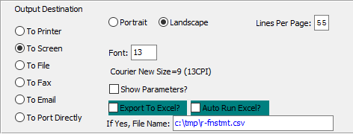

#### Destination Choice

To choose the destination where the document should be printed, please make sure that desired output destination choice bubble is toggled.

#### Layout Choice

To choose the preferred layout of Landscape vs. Portrait, please make sure the desired option choice bubbled is toggled.

#### Lines Per Page

Lines per page on the report when printing.

#### Font

Enter the font number to use with this report (Font 11 is default).

#### Show Parameters? – Toggle Box

To show parameters, make sure that the toggle box is ‘ticked’ with a checkmark.

#### Export to Excel? – Toggle Box

To export the printed file to an excel document, make sure that the Export to Excel toggle box is checked.

#### Auto Run Excel? – Toggle Box

To automatically open the new excel document, make sure that the Auto Run Excel toggle box is checked.

#### If Yes, File Name

If exporting the file to Excel, enter the desired file name.

## Report Maintenance [GW2]

The header provides the layout definition for the financial report including Report Headings which print at the top of the Page, Column Heading which print at the top of Each Column and Sub Totals Headings which print on the left-hand column. A maximum of nine columns and up to twelve sub-totals are currently supported.

### Browse Report

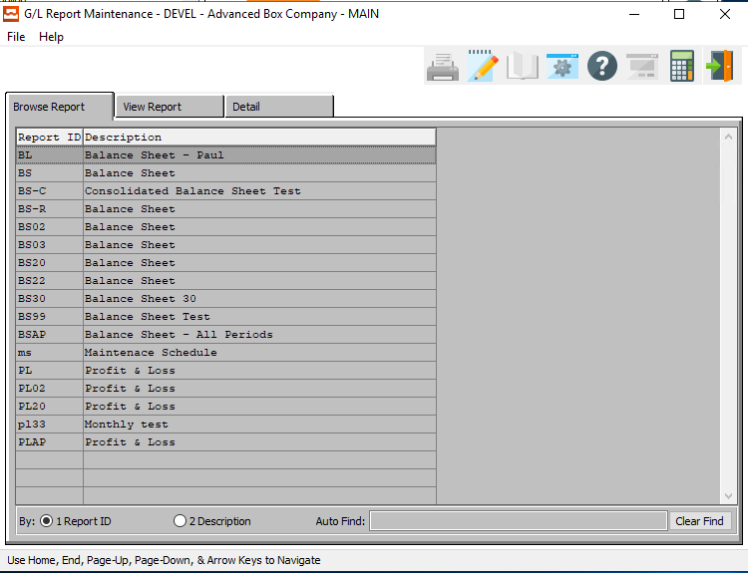

### View Report

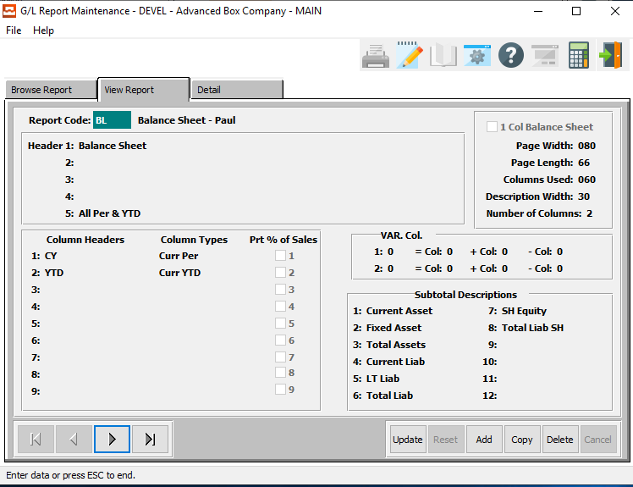

#### UPDATE

To change an report, simply click the ***“Update***” button at the bottom of the screen.

#### ADD

Click the ***“Add”*** button to add a new report.

#### COPY

Click the ***“Copy”*** button to copy information from the currently selected report.

#### DELETE

To delete a report, simply press the ***"D"*** key. Alternatively, click the ***“Delete”*** button at the bottom of the screen.

#### NEXT

Press ***"N"*** (Next) to find next report to view or modify. Alternatively, press the ***“Right Arrow”*** on the screen.

#### PREVIOUS

Press ***"P"*** (Previous) to find previous report to view or modify. Alternatively, press the ***“Left Arrow”*** on the screen.

### Add/Update Report

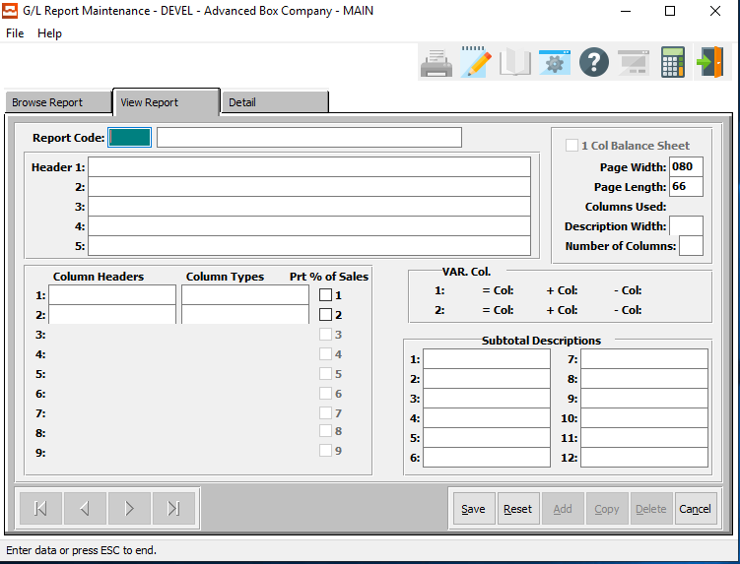

#### SAVE

Click the ***“Save”*** button to save all changes to the current report.

#### RESET

Click the ***“Reset”*** button to reset all fields to their original state.

#### CANCEL

Click the ***“Cancel”*** button to cancel all changes to the report without saving.

### Add/Update Report Field Definitions

#### Report Code

Enter a five-character alphanumeric code which defines a unique financial report such as P&L for Profit & Loss or BS for Balance Sheet. This Report Code must be unique for each company, but the same report code can repeat in different companies. In the Sample Database, we have defined one sample Profit & Loss Report (PL01).

#### Report Name

Enter a Report Name to define this financial statement.

#### Page Headers

Enter up to five lines of description for the Report Heading which will print at the top of each page on the financial report. The fifth line will default to the description field on the screen when printing financial statements.

#### Column Headers

Enter a user defined Heading Description that corresponds to the column type. i.e. the description entered for column one corresponds to the column type 1.

#### Column Types

Press “***F1”*** or the ***“Page Up”*** / ***“Page Down”*** keys to search for a valid column type.

Please Note: All codes may be used is they fit on the width of the paper.

Valid Column Types are as Follows:

|  |  |  |
| --- | --- | --- |
| Budget Current Period to Date | Current Period | Last Year Current Period |
| Budget Quarter to Date | Current Quarter to Date | Last Year Quarter to Date |
| Budget Year to Date | Current Year to Date | Variance |

#### Print % of Sales – Toggle Box

To print percentages for the columns defined, make sure that each toggle box Is checked. This will calculate a percentage based on the cumulative total of the general ledger accounts in that range of accounts.

#### 1 Col Balance Sheet

To limit the financial report to just one column, make sure that this toggle box is checked. If the toggle box is checked, only one heading is allowed.

#### Page Width

Enter number of characters for your printer. For 8 1/2 by 11-inch paper enter 80 for ten pitch, 96 for 12 pitch or 120 for 15 pitch. For normal wide computer paper, enter 132 for 10 pitch, 185 for 12 pitch, or 198 for 15 pitch.

Please Note: Your printer must support the desires width.

#### Page Length

Enter number of characters for your printer.

#### Columns Used

The total of number of columns used will automatically be calculated based on the width of the column and the number of columns used.

#### Description Width

Enter the number of characters to print on the column heading.

#### Number of Columns

Enter the total of number of columns to print on this report. The number entered will allow the definition of data in the column headers and column type fields.

#### Variance Col. 1

Enter a column number to add or subtract from another column to create a variance for column one.

#### Add Col. 1

Enter the column number to add to the variance column 1.

#### Sub Col. 1

Enter the column number to subtract form the variance column 1.

#### Variance Col. 2

Enter a column number to add or subtract from another column to create a variance for column two.

#### Add Col. 2

Enter the column number to add to the variance column 2.

#### Sub Col. 2

Enter the column number to subtract form the variance column 2.

#### Subtotal Descriptions

The sub total headings may be defined for each financial report. A maximum of twelve 13-character sub-totals are currently supported for each report. Once defined, the sub-totals display on the Report Writers Detail section when defining the unique general ledger accounts.

A ***“Y”*** (Yes) character must be entered on the sub total field on the Detail section of the report writer for the general ledger numbers to be added to that sub-total.

### Detail

The range and/or list of valid general ledger number and description of sub-total heading must be defined on the details section of the report writer.

For example, the description box sales would be typed in the description field, the normal line type is Detail Credit Balance Multiple Lines which dictates the printing of all the General Ledger Accounts within the range. Lastly, all sub-total categories which include sales must have a ***“Y”*** (Yes) code.

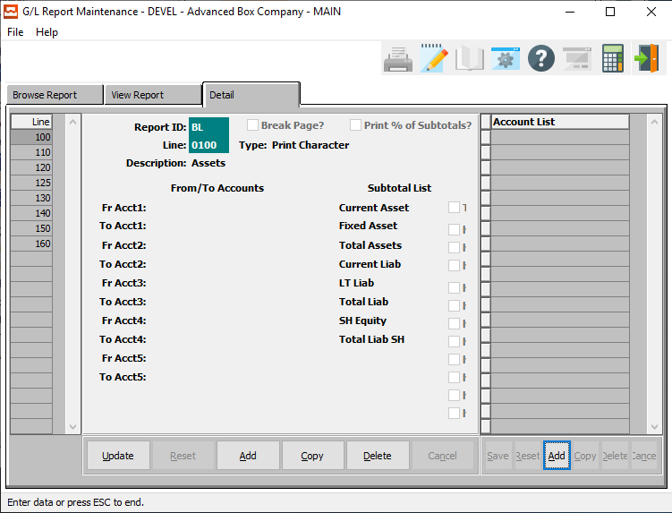

#### UPDATE

To change a detail, simply click the ***“Update***” button at the bottom of the screen.

#### ADD

Click the ***“Add”*** button at the bottom of the main section to add a new detail.

#### COPY

Click the ***“Copy”*** button to copy information from the currently selected detail.

#### DELETE

To delete a detail, simply press the ***"D"*** key. Alternatively, click the ***“Delete”*** button at the bottom of the screen.

### Add/Update Detail

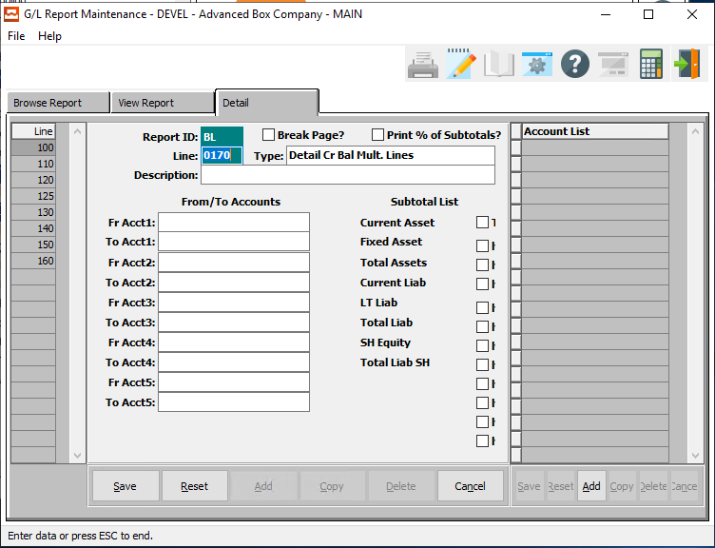

#### SAVE

Click the ***“Save”*** button to save all changes to the current detail.

#### RESET

Click the ***“Reset”*** button to reset all fields to their original state.

#### CANCEL

Click the ***“Cancel”*** button to cancel all changes to the detail without saving.

#### ADD (ACCOUNT LIST)

Click the ***“Add”*** button at the bottom of the Account List section to add a new account list.

### Add/Update Detail Field Definitions

#### Report ID

The report code transfers from the Reports Header Screen defined.

#### Break Page? – Toggle Box

To break up the pages between selection parameters, make sure that the Break Page toggle box is checked.

#### Print % of Subtotals? – Toggle Box

To print the percentage of subtotals, make sure that this toggle box is checked.

#### Line Number

The Line number designates the order in which the report will print. Line numbers do not have to be consecutive, however they have to be unique within the report definition.

We strongly suggest that you leave room between line numbers so that additional lines may be added if required later. The system automatically defaults the advances the numbers by 10. We start at 100 and advanced by ten to 110 ,120, 130, etc. If you think more room is needed between lines, then this number is modifiable.

#### Type

Line types tell the report writer what function to perform. Press the ***“Page Down”*** to scroll through the list of valid Report Writer Line Types:

#### Description

The description to print for this line on the financial report.

#### From / To Accounts

Enter the Starting and Ending Account number for a range of accounts to print for this report line. All accounts within this range are included on the report line.

### Add Account List

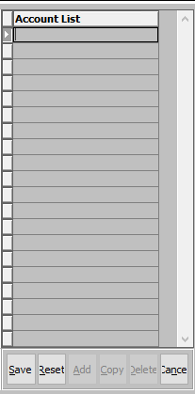

#### SAVE

Click the ***“Save”*** button to save all changes to the current account list.

#### RESET

Click the ***“Reset”*** button to reset all fields to their original state.

#### CANCEL

Click the ***“Cancel”*** button to cancel all changes to the account list without saving.

#### Account List

The user may enter each account number that they wish. Alternatively, press the ***“F1”*** button to choose a valid account number from a list of available accounts.

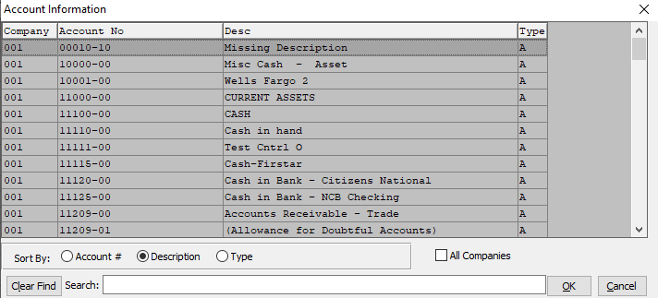

## Income Statement Ratios [GW3]

### Selection Parameters

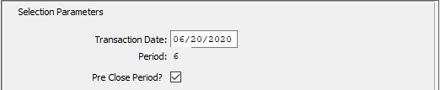

#### Transaction Date

Enter the transaction date for the posting of returns.

#### Period

This field is equal to the period associated with the transaction date.

#### Pre-Close Period? – Toggle Box

To pre-close the period, make sure that the Pre-Close Period toggle box is checked.

### Account Ranges

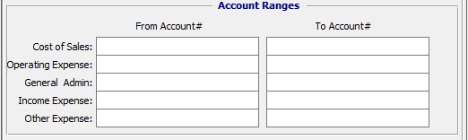

#### Cost of Sales – From Account # / To Account #

Enter the beginning and ending account number to run the Cost of Sales report for.

#### Operating Expense – From Account # / To Account #

Enter the beginning and ending account number to run the Operating Expense report for.

#### General Admin – From Account # / To Account #

Enter the beginning and ending account number to run the General Administration report for.

#### Income Expense – From Account # / To Account #

Enter the beginning and ending account number to run the Income Expense report for.

#### Other Expense – From Account # / To Account #

Enter the beginning and ending account number to run the Other Expense report for.

### Output Destination

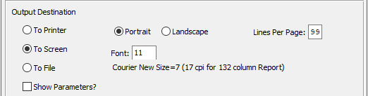

#### Destination Choice

To choose the destination where the document should be printed, please make sure that desired output destination choice bubble is toggled.

#### Layout Choice

To choose the preferred layout of Landscape vs. Portrait, please make sure the desired option choice bubbled is toggled.

#### Lines Per Page

Lines per page on the report when printing.

#### Font

Enter the font number to use with this report (Font 11 is default).

#### Show Parameters? – Toggle Box

To show parameters, make sure that the toggle box is ‘ticked’ with a checkmark.

# **Query General Ledger History [GQ]**

## GL Inquiry

This function will allow you to view on the screen, the opening balance for any account, all transactions posted to that account for the current accounting period, and display a current account balance. The system will display the Description of the Account, the Balance of the Account at the beginning of the month (or the end of last month) and each transaction will be displayed in the lower portion of the screen. You are then able to print all the transactions listed.

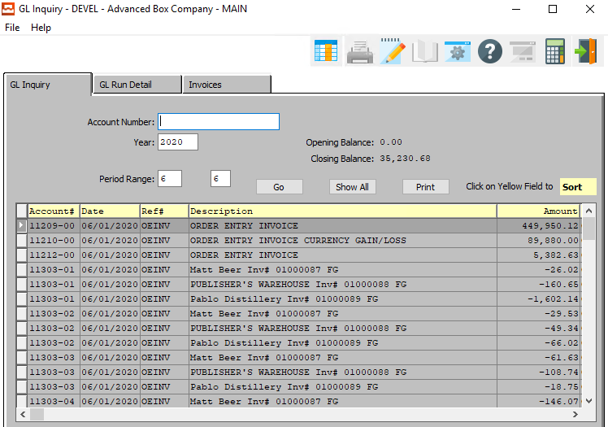

#### Account Number

Enter the account number or press the ***“F1”*** Function Key to search.

#### Year

Enter the year to inquire into.

#### Period Range

Enter the beginning and ending period to inquire into.

## GL Run Detail

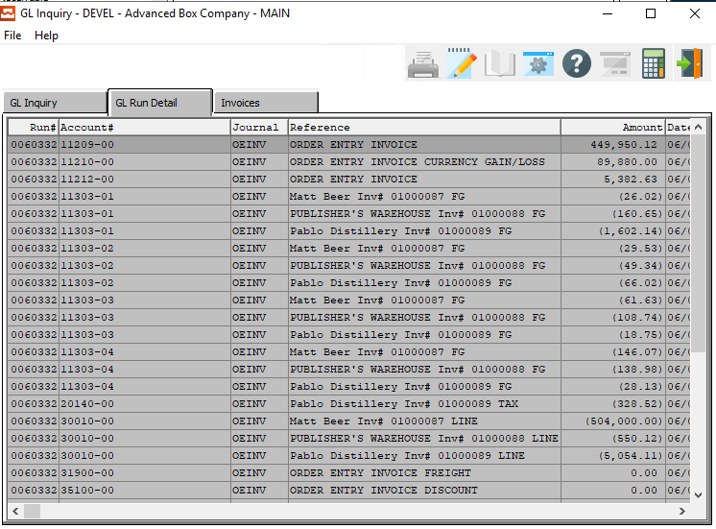

## Invoices

The GL Invoice Summary report provides the ability to print the total amount posted to each general ledger account number during invoice posting. During Order Processing Invoice posting, the program goes through every line item on the invoice.

If a category is available, it sums up the total amount for that category and puts the amount into that account number. The product category account number is defined in the item file. If a product category is not used, then it uses the invoice line item account number and sums up to that account number.

### Browse Invoices

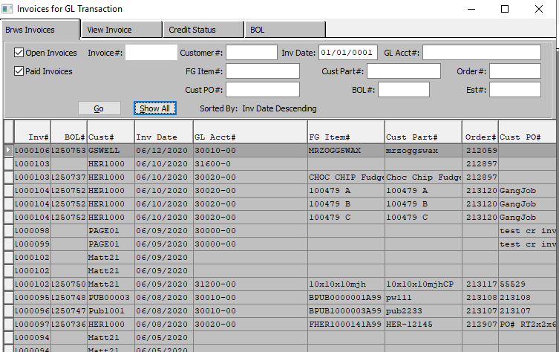

#### Open Invoices – Toggle Box

To search open invoices, make sure that the Open Invoices toggle box is checked.

#### Paid Invoices – Toggle Box

To search paid invoices, make sure that the Paid Invoices toggle box is checked.

#### Customer Number

Enter the Customer Number to search for. Alternatively, the user may press the ***“F1”*** key to select a number from a list of available Customers.

#### FG Item Number

Enter the Finished Good Item Number to search for. Alternatively, the user may press the ***“F1”*** key to select a number from a list of available Finished Good Items.

#### Customer PO Number

Enter the Customer Purchase Order Number to search for. Alternatively, the user may press the ***“F1”*** key to select a number from a list of available Purchase Orders.

#### GL Account Number

Enter the General Ledger Account Number to search for. Alternatively, the user may press the ***“F1”*** key to select a number from a list of available Accounts.

#### Customer Part Number

Enter the Customer Part Number to search for. Alternatively, the user may press the ***“F1”*** key to select a number from a list of available parts.

#### BOL Number

Enter the Bill of Lading Number to search for. Alternatively, the user may press the ***“F1”*** key to select a number from a list of available Bills of Lading.

#### Order Number

Enter the Order Number to search for. Alternatively, the user may press the ***“F1”*** key to select a number from a list of available orders.

#### Estimate Number

Enter the Estimate Number to search for. Alternatively, the user may press the ***“F1”*** key to select a number from a list of available Estimates.

### View Invoice

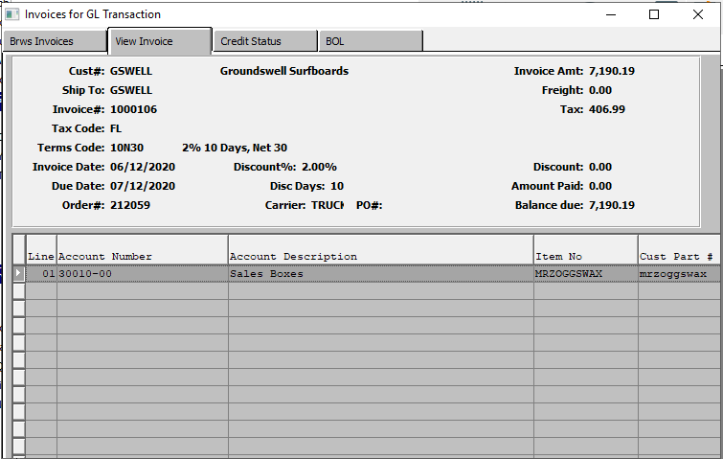

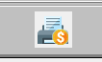

#### PRINT INVOICE

Click the ***“Printer Icon”*** to print the currently selected invoice to the system’s default printer.

### Credit Status

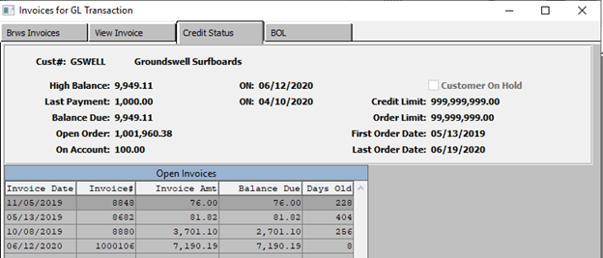

### BOL

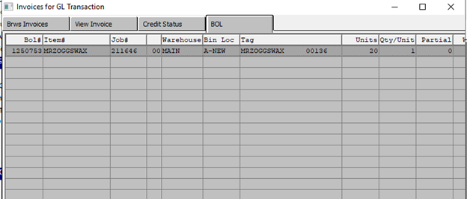



#### PRINTER ICON

Click the ***“Printer Icon”*** to print the selected Bill of Lading.

#### PAPER ICON

Click the ***“Paper and Pencil Icon”*** to print a selected Signed Bill of Lading”

From this screen, the signed Bill of Lading can be printed or displayed. Hence, invoice payment cannot be delayed because the customer cannot find the Bill of Lading or the inventory. Someone from their company signed, which means they received the goods.

# **Reports for General Ledger [GR]**

## Chart of Accounts [GR1]

Prints a list of the chart of accounts as defined in the General Ledger File Maintenance

To print a list of the chart of accounts, the system will prompt you as to whether or not you want to Send the output to the printer at this time.

### Selection Parameters

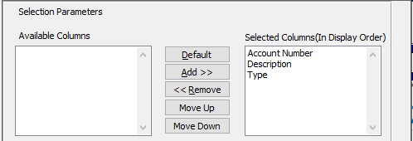

#### Available Columns

The user may choose which columns they wish to have on the report printout. As the user selects their choices, they will appear on the ‘*Selected Columns’* list.

#### Selected Columns (In Display Order)

The columns that the user has chosen from the ‘*Available Columns’* list. The order that these columns are displayed in here is the order in which they will print on the report.

#### Default

Click the ***“Default****”* button to sort the ‘*Selected Columns’* list by the default system parameters.

#### Add >>

Click on the selected item from the ‘*Available Columns’* list to highlight it, then click the ***“Add”*** button to add the selected column to the ‘*Selected Columns’* list.

#### << Remove

Click on the selected item from the ‘*Selected Columns’* list to highlight it, then click the ***“Remove”*** button to remove the selected column to the ‘*Selected Columns’* list.

#### Move Up

Within the ‘*Selected Columns’* list, the user may choose the order they wish the selected columns to print in. In order to change the order of the columns, the user can click on a selection to highlight it. By then clicking the ***“Move Up***” button, the user can change its position on the report.

#### Move Down

Within the ‘*Selected Columns’* list, the user may choose the order they wish the selected columns to print in. In order to change the order of the columns, the user can click on a selection to highlight it. By then clicking the ***“Move Down***” button, the user can change its position on the report.

### Output Destination

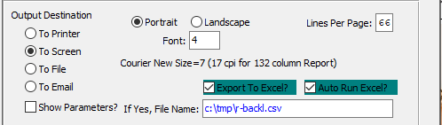

#### Destination Choice

To choose the destination where the document should be printed, please make sure that desired output destination choice bubble is toggled.

#### Layout Choice

To choose the preferred layout of Landscape vs. Portrait, please make sure the desired option choice bubbled is toggled.

#### Lines Per Page

Lines per page on the report when printing.

#### Font

Enter the font number to use with this report (Font 11 is default).

#### Show Parameters? – Toggle Box

To show parameters, make sure that the toggle box is ‘ticked’ with a checkmark.

#### Export to Excel? – Toggle Box

To export the printed file to an excel document, make sure that the Export to Excel toggle box is checked.

#### Auto Run Excel? – Toggle Box

To automatically open the new excel document, make sure that the Auto Run Excel toggle box is checked.

#### If Yes, File Name

If exporting the file to Excel, enter the desired file name.

## Current Month Detail [GR2]

Prints a detail or summary of all transactions entered for the current month in General Ledger Account order.

The month end report provides the ability to close the current period. A detail list of journal transactions will print prior to closing the period. Once closed, the month to data figures will be rolled into the year to date totals.

### Selection Parameters

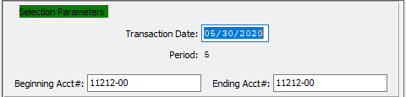

#### Transaction Date

Enter the desired transaction date.

#### Period

This field defaults to the period of the transaction date. The system will prompt you as to whether or not you want to Send the output to the printer at this time.

#### Beginning Account # / Ending Account #

Enter the beginning and ending account number to run the report for.

### Available and Selected Columns

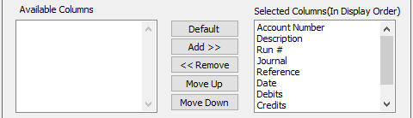

#### Available Columns

The user may choose which columns they wish to have on the report printout. As the user selects their choices, they will appear on the ‘*Selected Columns’* list.

#### Selected Columns (In Display Order)

The columns that the user has chosen from the ‘*Available Columns’* list. The order that these columns are displayed in here is the order in which they will print on the report.

#### Default

Click the ***“Default****”* button to sort the ‘*Selected Columns’* list by the default system parameters.

#### Add >>

Click on the selected item from the ‘*Available Columns’* list to highlight it, then click the ***“Add”*** button to add the selected column to the ‘*Selected Columns’* list.

#### << Remove

Click on the selected item from the ‘*Selected Columns’* list to highlight it, then click the ***“Remove”*** button to remove the selected column to the ‘*Selected Columns’* list.

#### Move Up

Within the ‘*Selected Columns’* list, the user may choose the order they wish the selected columns to print in. In order to change the order of the columns, the user can click on a selection to highlight it. By then clicking the ***“Move Up***” button, the user can change its position on the report.

#### Move Down

Within the ‘*Selected Columns’* list, the user may choose the order they wish the selected columns to print in. In order to change the order of the columns, the user can click on a selection to highlight it. By then clicking the ***“Move Down***” button, the user can change its position on the report.

### Output Destination

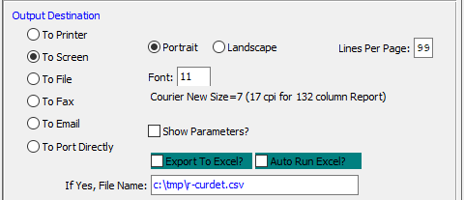

#### Destination Choice

To choose the destination where the document should be printed, please make sure that desired output destination choice bubble is toggled.

#### Layout Choice

To choose the preferred layout of Landscape vs. Portrait, please make sure the desired option choice bubbled is toggled.

#### Show Parameters? – Toggle Box

To show parameters, make sure that the toggle box is ‘ticked’ with a checkmark.

#### Export to Excel? – Toggle Box

To export the printed file to an excel document, make sure that the Export to Excel toggle box is checked.

#### Auto Run Excel? – Toggle Box

To automatically open the new excel document, make sure that the Auto Run Excel toggle box is checked.

#### If Yes, File Name

If exporting the file to Excel, enter the desired file name.

## Transaction Report [GR3]

Prints a detail report of all journal entries entered for the current period. It is printed in journal number order.

The journal activity report provides the ability to print a range of journal transactions to review by transaction date, by period, and for a range of journal numbers.

### Selection Parameters

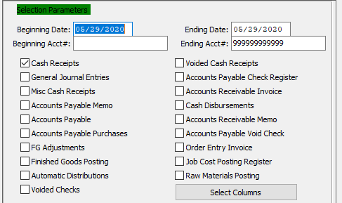

#### Beginning Date / Ending Date

Enter the date of the journal entry to start the report from, and the date of the journal entry to end the report on.

#### Beginning Account # / Ending Account #

Enter the beginning and ending account number to run the report for.

#### Cash Receipts – Toggle Box

To include Cash Receipts on the Transaction Report, make sure that the Cash Receipts toggle box is checked.

#### General Journal Entries – Toggle Box

To include General Journal Entries on the Transaction Report, make sure that this toggle box is checked.

#### Misc. Cash Receipts – Toggle Box

To include Miscellaneous Cash Receipts on the Transaction Report, make sure that the Misc. Cash Receipts toggle box is checked.

#### Accounts Payable Memo – Toggle Box

To include an Accounts Payable Memo on the Transaction Report, make sure that the Accounts Payable Memo toggle box is checked.

#### Accounts Payable – Toggle Box

To include the Accounts Payable on the Transaction Report, make sure that the Accounts Payable toggle box is checked.

#### Accounts Payable Purchases – Toggle Box

To include all Accounts Payable Purchases on the Transaction Report, make sure that this toggle box is checked.

#### FG Adjustments – Toggle Box

To include all Finished Good Adjustments on the Transaction Report, make sure that the FG Adjustments toggle box is checked.

#### Finished Goods Posting – Toggle Box

To include Posted Finished Goods on the Transaction Report, make sure that the Finished Goods Posting toggle box is checked.

#### Automatic Distributions – Toggle Box

To include Automatic Distributions on the Transaction Report, make sure that the Automatic Distributions toggle box is checked.

#### Voided Checks – Toggle Box

To include Voided Checks on the Transaction Report, make sure that the Voided Checks toggle box is checked.

#### Voided Cash Receipts – Toggle Box

To include Voided Cash Receipts on the Transaction Report, make sure that the Voided Cash Receipts toggle box is checked.

#### Accounts Payable Check Register – Toggle Box

To include the Accounts Payable Check Register on the Transaction Report, make sure that the Accounts Payable Check Register toggle box is checked.

#### Accounts Receivable Invoice – Toggle Box

To include Accounts Receivable Invoices on the Transaction Report, make sure that this toggle box is checked.

#### Cash Disbursements – Toggle Box

To include Cash Disbursements on the Transaction Report, make sure that the Cash Disbursements toggle box is checked.

#### Accounts Receivable Memo – Toggle Box

To include Accounts Receivable Memos on the Transaction Report, make sure that this toggle box is checked.

#### Accounts Payable Void Check – Toggle Box

To include Accounts Payable Voided Checks on the Transaction Report, make sure that this toggle box is checked.

#### Order Entry Invoice – Toggle Box

To include Order Entry Invoices on the Transaction Report, make sure that the Order Entry Invoice toggle box is checked.

#### Job Cost Posting Register – Toggle Box

To include Job Cost Posting Registers on the Transaction Report, make sure that this toggle box is checked.

#### Raw Materials Posting – Toggle Box

To include Raw Materials Posting on the Transaction Report, make sure that this toggle box is checked.

### Available and Selected Columns

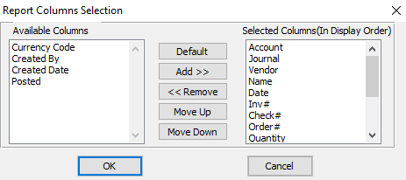

#### Available Columns

The user may choose which columns they wish to have on the report printout. As the user selects their choices, they will appear on the ‘*Selected Columns’* list.

#### Selected Columns (In Display Order)

The columns that the user has chosen from the ‘*Available Columns’* list. The order that these columns are displayed in here is the order in which they will print on the report.

#### Default

Click the ***“Default****”* button to sort the ‘*Selected Columns’* list by the default system parameters.

#### Add >>

Click on the selected item from the ‘*Available Columns’* list to highlight it, then click the ***“Add”*** button to add the selected column to the ‘*Selected Columns’* list.

#### << Remove

Click on the selected item from the ‘*Selected Columns’* list to highlight it, then click the ***“Remove”*** button to remove the selected column to the ‘*Selected Columns’* list.

#### Move Up

Within the ‘*Selected Columns’* list, the user may choose the order they wish the selected columns to print in. In order to change the order of the columns, the user can click on a selection to highlight it. By then clicking the ***“Move Up***” button, the user can change its position on the report.

#### Move Down

Within the ‘*Selected Columns’* list, the user may choose the order they wish the selected columns to print in. In order to change the order of the columns, the user can click on a selection to highlight it. By then clicking the ***“Move Down***” button, the user can change its position on the report.

### Output Destination

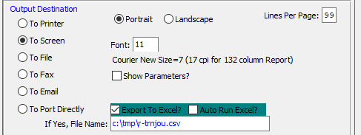

#### Destination Choice

To choose the destination where the document should be printed, please make sure that desired output destination choice bubble is toggled.

#### Layout Choice

To choose the preferred layout of Landscape vs. Portrait, please make sure the desired option choice bubbled is toggled.

#### Lines Per Page

Lines per page on the report when printing.

#### Font

Enter the font number to use with this report (Font 11 is default).

#### Show Parameters? – Toggle Box

To show parameters, make sure that the toggle box is ‘ticked’ with a checkmark.

#### Export to Excel? – Toggle Box

To export the printed file to an excel document, make sure that the Export to Excel toggle box is checked.

#### Auto Run Excel? – Toggle Box

To automatically open the new excel document, make sure that the Auto Run Excel toggle box is checked.

#### If Yes, File Name

If exporting the file to Excel, enter the desired file name.

## GL Invoice Summary [GR4]

### Selection Parameters

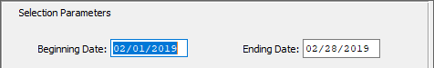

#### Beginning Date / Ending Date

Enter the beginning and ending invoice date to run the report for.

### Available and Selected Columns

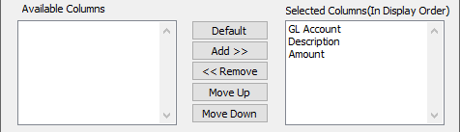

#### Available Columns

The user may choose which columns they wish to have on the report printout. As the user selects their choices, they will appear on the ‘*Selected Columns’* list.

#### Selected Columns (In Display Order)

The columns that the user has chosen from the ‘*Available Columns’* list. The order that these columns are displayed in here is the order in which they will print on the report.

#### Default

Click the ***“Default****”* button to sort the ‘*Selected Columns’* list by the default system parameters.

#### Add >>

Click on the selected item from the ‘*Available Columns’* list to highlight it, then click the ***“Add”*** button to add the selected column to the ‘*Selected Columns’* list.

#### << Remove

Click on the selected item from the ‘*Selected Columns’* list to highlight it, then click the ***“Remove”*** button to remove the selected column to the ‘*Selected Columns’* list.

#### Move Up

Within the ‘*Selected Columns’* list, the user may choose the order they wish the selected columns to print in. In order to change the order of the columns, the user can click on a selection to highlight it. By then clicking the ***“Move Up***” button, the user can change its position on the report.

#### Move Down

Within the ‘*Selected Columns’* list, the user may choose the order they wish the selected columns to print in. In order to change the order of the columns, the user can click on a selection to highlight it. By then clicking the ***“Move Down***” button, the user can change its position on the report.

### Output Destination

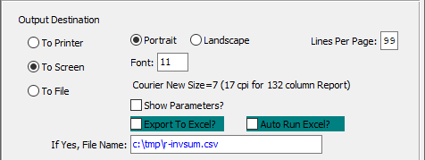

#### Destination Choice

To choose the destination where the document should be printed, please make sure that desired output destination choice bubble is toggled.

#### Layout Choice

To choose the preferred layout of Landscape vs. Portrait, please make sure the desired option choice bubbled is toggled.

#### Lines Per Page

Lines per page on the report when printing.

#### Font

Enter the font number to use with this report (Font 11 is default).

#### Show Parameters? – Toggle Box

To show parameters, make sure that the toggle box is ‘ticked’ with a checkmark.

#### Export to Excel? – Toggle Box

To export the printed file to an excel document, make sure that the Export to Excel toggle box is checked.

#### Auto Run Excel? – Toggle Box

To automatically open the new excel document, make sure that the Auto Run Excel toggle box is checked.

#### If Yes, File Name

If exporting the file to Excel, enter the desired file name.

## GL History [GR5]

### Selection Parameters

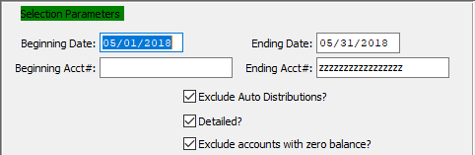

#### Beginning Date / Ending Date

Enter the beginning and ending date to run the report for.

#### Beginning Account # / Ending Account #

Enter the beginning and ending account number to run the report for.

#### Exclude Auto Distributions? – Toggle Box

To exclude automatic distributions in the general ledger history report, make sure that this toggle box is checked.

#### Detailed? – Toggle Box

To print a detailed history report, make sure that the Detailed toggle box is checked.

#### Exclude Accounts with Zero Balance? – Toggle Box

To exclude all accounts that have a zero balance, make sure that this toggle box is checked.

### Available and Selected Columns

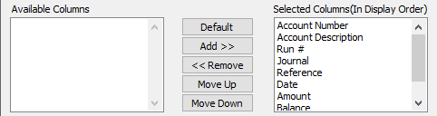

#### Available Columns

The user may choose which columns they wish to have on the report printout. As the user selects their choices, they will appear on the ‘*Selected Columns’* list.

#### Selected Columns (In Display Order)

The columns that the user has chosen from the ‘*Available Columns’* list. The order that these columns are displayed in here is the order in which they will print on the report.

#### Default

Click the ***“Default****”* button to sort the ‘*Selected Columns’* list by the default system parameters.

#### Add >>

Click on the selected item from the ‘*Available Columns’* list to highlight it, then click the ***“Add”*** button to add the selected column to the ‘*Selected Columns’* list.

#### << Remove

Click on the selected item from the ‘*Selected Columns’* list to highlight it, then click the ***“Remove”*** button to remove the selected column to the ‘*Selected Columns’* list.

#### Move Up

Within the ‘*Selected Columns’* list, the user may choose the order they wish the selected columns to print in. In order to change the order of the columns, the user can click on a selection to highlight it. By then clicking the ***“Move Up***” button, the user can change its position on the report.

#### Move Down

Within the ‘*Selected Columns’* list, the user may choose the order they wish the selected columns to print in. In order to change the order of the columns, the user can click on a selection to highlight it. By then clicking the ***“Move Down***” button, the user can change its position on the report.

### Output Destination

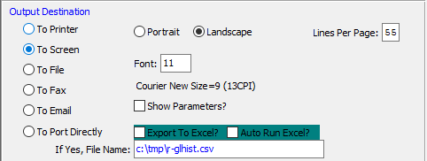

#### Destination Choice

To choose the destination where the document should be printed, please make sure that desired output destination choice bubble is toggled.

#### Layout Choice

To choose the preferred layout of Landscape vs. Portrait, please make sure the desired option choice bubbled is toggled.

#### Show Parameters? – Toggle Box

To show parameters, make sure that the toggle box is ‘ticked’ with a checkmark.

#### Export to Excel? – Toggle Box

To export the printed file to an excel document, make sure that the Export to Excel toggle box is checked.

#### Auto Run Excel? – Toggle Box

To automatically open the new excel document, make sure that the Auto Run Excel toggle box is checked.

#### If Yes, File Name

If exporting the file to Excel, enter the desired file name.

## GL Posting Register [GR6]

### Selection Parameters

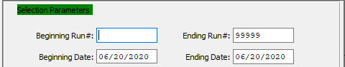

#### Beginning Run # / Ending Run #

Enter the beginning and ending run number to run the report for.

#### Beginning Date / Ending Date

Enter the beginning and ending posting date to run the report for.

### Available and Selected Columns

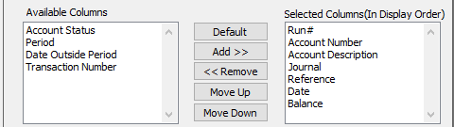

#### Available Columns

The user may choose which columns they wish to have on the report printout. As the user selects their choices, they will appear on the ‘*Selected Columns’* list.

#### Selected Columns (In Display Order)

The columns that the user has chosen from the ‘*Available Columns’* list. The order that these columns are displayed in here is the order in which they will print on the report.

#### Default

Click the ***“Default****”* button to sort the ‘*Selected Columns’* list by the default system parameters.

#### Add >>

Click on the selected item from the ‘*Available Columns’* list to highlight it, then click the ***“Add”*** button to add the selected column to the ‘*Selected Columns’* list.

#### << Remove

Click on the selected item from the ‘*Selected Columns’* list to highlight it, then click the ***“Remove”*** button to remove the selected column to the ‘*Selected Columns’* list.

#### Move Up

Within the ‘*Selected Columns’* list, the user may choose the order they wish the selected columns to print in. In order to change the order of the columns, the user can click on a selection to highlight it. By then clicking the ***“Move Up***” button, the user can change its position on the report.

#### Move Down

Within the ‘*Selected Columns’* list, the user may choose the order they wish the selected columns to print in. In order to change the order of the columns, the user can click on a selection to highlight it. By then clicking the ***“Move Down***” button, the user can change its position on the report.

### Output Destination

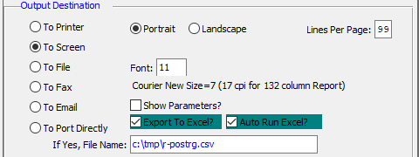

#### Destination Choice

To choose the destination where the document should be printed, please make sure that desired output destination choice bubble is toggled.

#### Layout Choice

To choose the preferred layout of Landscape vs. Portrait, please make sure the desired option choice bubbled is toggled.

#### Lines Per Page

Lines per page on the report when printing.

#### Font

Enter the font number to use with this report (Font 11 is default).

#### Show Parameters? – Toggle Box

To show parameters, make sure that the toggle box is ‘ticked’ with a checkmark.

#### Export to Excel? – Toggle Box

To export the printed file to an excel document, make sure that the Export to Excel toggle box is checked.

#### Auto Run Excel? – Toggle Box

To automatically open the new excel document, make sure that the Auto Run Excel toggle box is checked.

#### If Yes, File Name

If exporting the file to Excel, enter the desired file name.

## GL Posting Check [GR7]

### Selection Parameters

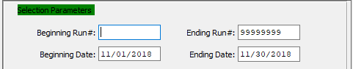

#### Beginning Run # / Ending Run #

Enter the beginning and ending run number to run the report for.

#### Beginning Date / Ending Date

Enter the beginning and ending posting check date to run the report for.

### Available and Selected Columns

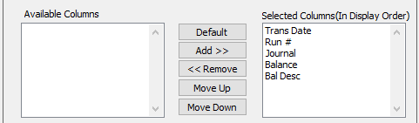

#### Available Columns

The user may choose which columns they wish to have on the report printout. As the user selects their choices, they will appear on the ‘*Selected Columns’* list.

#### Selected Columns (In Display Order)

The columns that the user has chosen from the ‘*Available Columns’* list. The order that these columns are displayed in here is the order in which they will print on the report.

#### Default

Click the ***“Default****”* button to sort the ‘*Selected Columns’* list by the default system parameters.

#### Add >>

Click on the selected item from the ‘*Available Columns’* list to highlight it, then click the ***“Add”*** button to add the selected column to the ‘*Selected Columns’* list.

#### << Remove

Click on the selected item from the ‘*Selected Columns’* list to highlight it, then click the ***“Remove”*** button to remove the selected column to the ‘*Selected Columns’* list.

#### Move Up

Within the ‘*Selected Columns’* list, the user may choose the order they wish the selected columns to print in. In order to change the order of the columns, the user can click on a selection to highlight it. By then clicking the ***“Move Up***” button, the user can change its position on the report.

#### Move Down

Within the ‘*Selected Columns’* list, the user may choose the order they wish the selected columns to print in. In order to change the order of the columns, the user can click on a selection to highlight it. By then clicking the ***“Move Down***” button, the user can change its position on the report.

### Output Destination

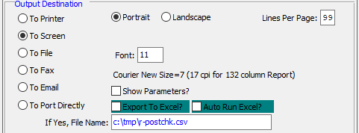

#### Destination Choice

To choose the destination where the document should be printed, please make sure that desired output destination choice bubble is toggled.

#### Layout Choice

To choose the preferred layout of Landscape vs. Portrait, please make sure the desired option choice bubbled is toggled.

#### Lines Per Page

Lines per page on the report when printing.

#### Font

Enter the font number to use with this report (Font 11 is default).

#### Show Parameters? – Toggle Box

To show parameters, make sure that the toggle box is ‘ticked’ with a checkmark.

#### Export to Excel? – Toggle Box

To export the printed file to an excel document, make sure that the Export to Excel toggle box is checked.

#### Auto Run Excel? – Toggle Box

To automatically open the new excel document, make sure that the Auto Run Excel toggle box is checked.

#### If Yes, File Name

If exporting the file to Excel, enter the desired file name.

## Reference Date vs. Posting Date [GR8]

### Selection Parameters

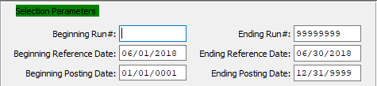

#### Beginning Run # / Ending Run #

Enter the beginning and ending run number to run the report for.

#### Beginning Reference Date / Ending Reference Date

Enter the beginning and ending reference date to run the report for.

#### Beginning Posting Date / Ending Posting Date

Enter the beginning and ending posting date to run the report for.

### Available and Selected Columns

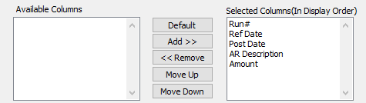

#### Available Columns

The user may choose which columns they wish to have on the report printout. As the user selects their choices, they will appear on the ‘*Selected Columns’* list.

#### Selected Columns (In Display Order)

The columns that the user has chosen from the ‘*Available Columns’* list. The order that these columns are displayed in here is the order in which they will print on the report.

#### Default

Click the ***“Default****”* button to sort the ‘*Selected Columns’* list by the default system parameters.

#### Add >>

Click on the selected item from the ‘*Available Columns’* list to highlight it, then click the ***“Add”*** button to add the selected column to the ‘*Selected Columns’* list.

#### << Remove

Click on the selected item from the ‘*Selected Columns’* list to highlight it, then click the ***“Remove”*** button to remove the selected column to the ‘*Selected Columns’* list.

#### Move Up

Within the ‘*Selected Columns’* list, the user may choose the order they wish the selected columns to print in. In order to change the order of the columns, the user can click on a selection to highlight it. By then clicking the ***“Move Up***” button, the user can change its position on the report.

#### Move Down

Within the ‘*Selected Columns’* list, the user may choose the order they wish the selected columns to print in. In order to change the order of the columns, the user can click on a selection to highlight it. By then clicking the ***“Move Down***” button, the user can change its position on the report.

### Output Destination

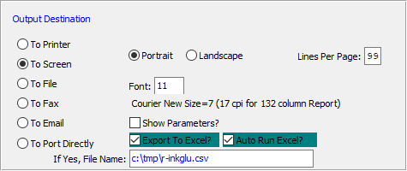

#### Destination Choice

To choose the destination where the document should be printed, please make sure that desired output destination choice bubble is toggled.

#### Layout Choice

To choose the preferred layout of Landscape vs. Portrait, please make sure the desired option choice bubbled is toggled.

#### Lines Per Page

Lines per page on the report when printing.

#### Show Parameters? – Toggle Box

To show parameters, make sure that the toggle box is ‘ticked’ with a checkmark.

#### Export to Excel? – Toggle Box

To export the printed file to an excel document, make sure that the Export to Excel toggle box is checked.

#### Auto Run Excel? – Toggle Box

To automatically open the new excel document, make sure that the Auto Run Excel toggle box is checked.

#### If Yes, File Name

If exporting the file to Excel, enter the desired file name.

## Journal Entries Report [GR9]

### Selection Parameters

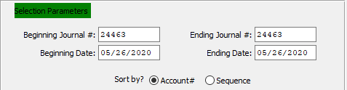

#### Beginning Journal # / Ending Journal #

Enter the beginning and ending journal number to run the report for.

#### Beginning Date / Ending Date

Enter the beginning and ending journal entry date to run the report for.

### Available and Selected Columns

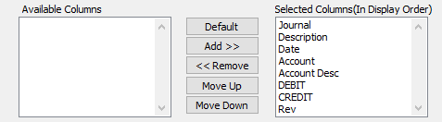

#### Available Columns

The user may choose which columns they wish to have on the report printout. As the user selects their choices, they will appear on the ‘*Selected Columns’* list.

#### Selected Columns (In Display Order)

The columns that the user has chosen from the ‘*Available Columns’* list. The order that these columns are displayed in here is the order in which they will print on the report.

#### Default

Click the ***“Default****”* button to sort the ‘*Selected Columns’* list by the default system parameters.

#### Add >>

Click on the selected item from the ‘*Available Columns’* list to highlight it, then click the ***“Add”*** button to add the selected column to the ‘*Selected Columns’* list.

#### << Remove

Click on the selected item from the ‘*Selected Columns’* list to highlight it, then click the ***“Remove”*** button to remove the selected column to the ‘*Selected Columns’* list.

#### Move Up

Within the ‘*Selected Columns’* list, the user may choose the order they wish the selected columns to print in. In order to change the order of the columns, the user can click on a selection to highlight it. By then clicking the ***“Move Up***” button, the user can change its position on the report.

#### Move Down

Within the ‘*Selected Columns’* list, the user may choose the order they wish the selected columns to print in. In order to change the order of the columns, the user can click on a selection to highlight it. By then clicking the ***“Move Down***” button, the user can change its position on the report.

### Output Destination

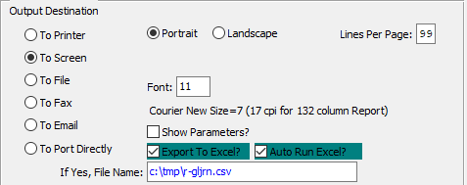

#### Destination Choice

To choose the destination where the document should be printed, please make sure that desired output destination choice bubble is toggled.

#### Layout Choice

To choose the preferred layout of Landscape vs. Portrait, please make sure the desired option choice bubbled is toggled.

#### Lines Per Page

Lines per page on the report when printing.

#### Font

Enter the font number to use with this report (Font 11 is default).

#### Show Parameters? – Toggle Box

To show parameters, make sure that the toggle box is ‘ticked’ with a checkmark.

#### Export to Excel? – Toggle Box

To export the printed file to an excel document, make sure that the Export to Excel toggle box is checked.

#### Auto Run Excel? – Toggle Box

To automatically open the new excel document, make sure that the Auto Run Excel toggle box is checked.

#### If Yes, File Name

If exporting the file to Excel, enter the desired file name.

# **File Maintenance for General Ledger [GF]**

## Overview

#### Company File

Used to define company information. It is here where the general ledger account number levels are defined, calendar month of year end, and all beginning and ending dates for all periods are defined.

#### GL/Accounts File

This is where the chart of accounts is set up. It is also used to set up or view the current year open balance and Last year open balance. The history of an account number can also be accessed from this screen.

#### G/L Control File

This screen is used to control all postings for general ledger transactions. Your retained earnings and profit contra account are set up here. The default journal number and default transaction number are controlled in this file.

#### Bank File

Used to define all bank account information. Several bank accounts can be set up here, each with their own general ledger account number. The screen displays name of bank, address, telephone number, contact name, bank account number, last check number used and bank account balance.

## Company [GF1]

Up to 999 company codes are supported. Each company will have a unique database including customers, machines, vendors, etc. Company ZZZ includes a pre-defined database that can save time if utilized. Press ***"C"*** (Change) to modify details for company ZZZ. To create a new company, press the ***"A"*** (Add) key.

Please Note: All files must also be created in the sequence listed in the user’s manual. To delete a company, press ***"D"*** (Delete).

Please Note: All supporting files should be deleted before deleting the company file.

### Browse Company

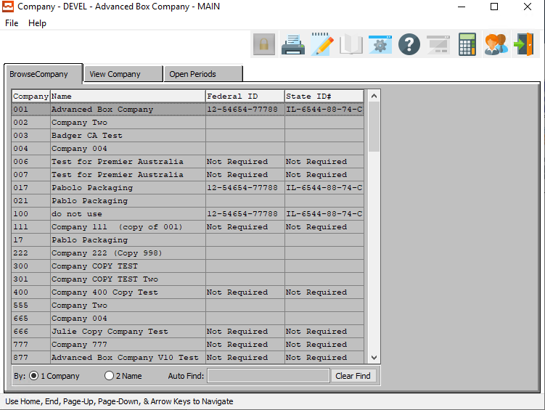

### View Company

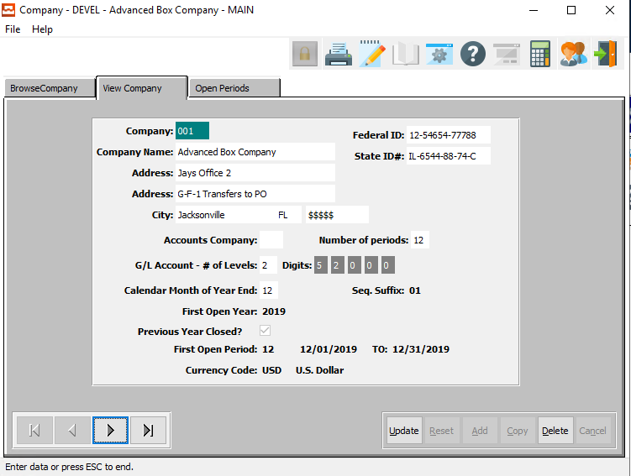

#### UPDATE

To change a company, simply click the ***“Update***” button at the bottom of the screen.

#### DELETE

To delete a company, simply press the ***"D"*** key. Alternatively, click the ***“Delete”*** button at the bottom of the screen.

#### NEXT

Press ***"N"*** (Next) to find next company to view or modify. Alternatively, press the ***“Right Arrow”*** on the screen.

#### PREVIOUS

Press ***"P"*** (Previous) to find previous company to view or modify. Alternatively, press the ***“Left Arrow”*** on the screen.

### Add/Update Company

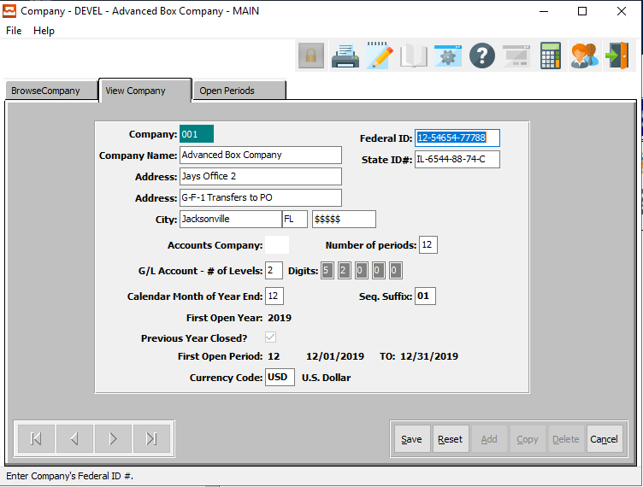

#### SAVE

Click the ***“Save”*** button to save all changes to the current company.

#### RESET

Click the ***“Reset”*** button to reset all fields to their original state.

#### CANCEL

Click the ***“Cancel”*** button to cancel all changes to the company without saving.

### Add/Update Company Field Definitions

#### Company

Enter a unique company code. The company will be referenced in all modules by this code. If you loaded the Demo database, then company 'ZZZ' is the code for the DEMO company "ADVANCED BOX COMPANY".

#### Company Name

Enter the company name. This is the name you want to appear at the top of all reports.

#### Company Address Line 1

Enter the first line of the company address.

#### Company Address Line 2

Enter the second line of the company address. This line can be skipped if not needed.

#### City

Enter the company's city.

#### State

Enter the company's state.

#### Zip/Postal Code

Enter the company's zip code.

#### Federal ID #

Enter the company's Federal ID number (EIN).

#### State ID #

Enter the company's State ID number.

#### Accounts Company

If you want to copy an existing company's G/L chart of accounts, then enter that company's (Company Code).

#### Number of Periods

Enter the number of accounting Periods used per year with the maximum being 13. Some Companies use one accounting period per month, and use the thirteenth period for adjustments.

#### G/L Account – Number of Levels

A company can use a maximum of 5 with nine digits in each level which serve to categorize G/L account numbers by company, department, work center, branches, etc.

#### Digits

This defines the number of digits in each level. For example, if your G/L account number is 5000-02, the number of levels would equal 2, with 4 digits and 2 digits respectively.

#### Calendar Month of Year End

Enter the last month of your fiscal (or calendar) accounting year.

#### First Open Year

Enter the first year in which you want to acquire information. In some cases, companies use last year as the first open year so they can use last year's history accounting information for comparison purposes.

#### First Open Period

Enter the number of the first open period of the current fiscal (or calendar) year.

#### Currency Code

Add the currency code of the country. Use ***“F1”*** for a look up of the code that you are looking for.

### Open Periods

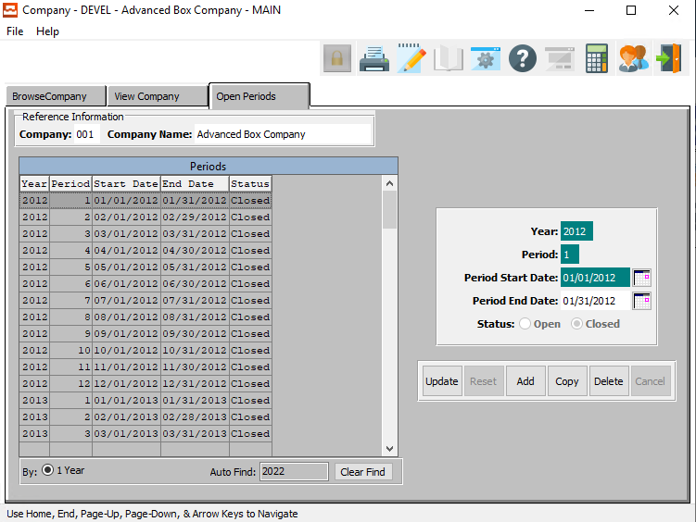

#### UPDATE

To change a period, simply click the ***“Update***” button at the bottom of the screen.

#### ADD

Click the ***“Add”*** button to add a new period.

#### COPY

Click the ***“Copy”*** button to copy information from the currently selected period.

#### DELETE

To delete a period, simply press the ***"D"*** key. Alternatively, click the ***“Delete”*** button at the bottom of the screen.

### Add/Update Open Periods

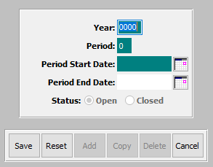

#### SAVE

Click the ***“Save”*** button to save all changes to the current period.

#### RESET

Click the ***“Reset”*** button to reset all fields to their original state.

#### CANCEL

Click the ***“Cancel”*** button to cancel all changes to the period without saving.

### Add/Update Open Period Field Definitions

#### Year

The user may enter the period they wish to open.

#### Period

This field is equal to the period associated with the transaction date.

#### Period Start Date / Period End Date

Enter the starting and ending date of the period.

## GL Accounts [GF2]

### Overview

As mentioned earlier, each General Ledger Account maintains a 2-year account history and a 1-year budget. To display these figures, press the ***"H"*** (History) key. Press ***"F"*** (Find) to search for the account and have it displayed on the screen to make it active.

The first 2 columns of information, Current and Last Year, represent the net effects of monthly transactions closed to this account (note: that the figures DO NOT represent the account balance at the end of the period, but the net change to the account during the month - debits are positive numbers, credits are negative numbers).

The budgets column represents the user defined budgeted amounts for this account on a monthly basis. The information in the first 2 columns is updated by the system when the MONTH END close function is performed. The figures in the Current or 1 Year Ago columns display either a net Debit or Credit to the Account.

The account history fields are updated when the Month End Report option is completed, and the period is CLOSED. If a closed period is reopened, then the history fields remain the same as before the period was reopened, and are updated only when the period is reclosed. The management report function of the system directly uses these figures when generating the management reports (defined in the General Ledger Report Writer)

### Browse Accounts

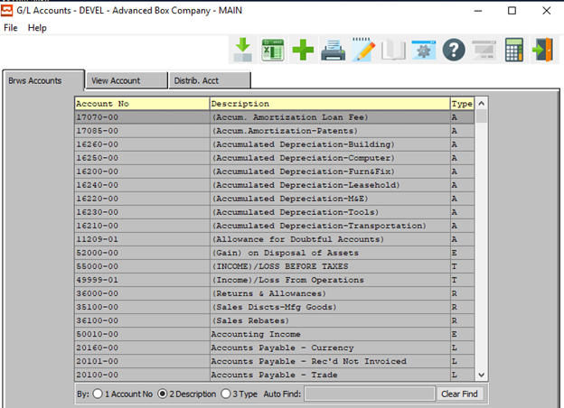

#### ADD

Click the ***“Green + Icon”*** to add a new account.

### View Account

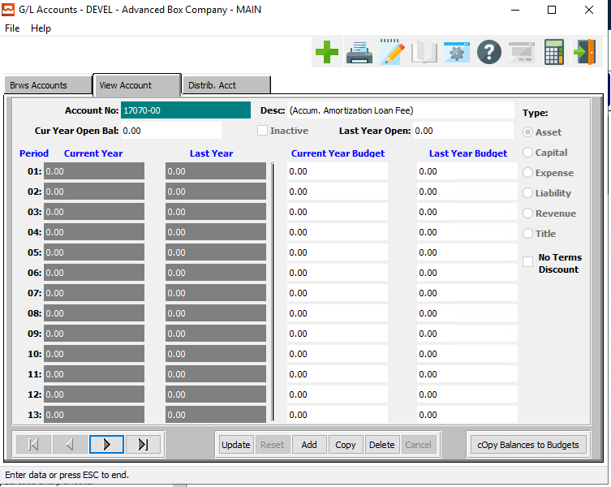

#### ADD

To add an account, simply click the ***“Green + Icon”*** button at the top of the Accounts screen.

Alternatively, click the ***“Add”*** button at the bottom of the screen.

#### COPY

Click the ***“Copy”*** button to copy information from the currently selected account.

#### DELETE

To delete an account, simply press the ***"D"*** key. Alternatively, click the ***“Delete”*** button at the bottom of the screen.

#### NEXT

Press ***"N"*** (Next) to find next account to view or modify. Alternatively, press the ***“Right Arrow”*** on the screen.

#### PREVIOUS

Press ***"P"*** (Previous) to find previous account to view or modify. Alternatively, press the ***“Left Arrow”*** on the screen.

#### COPY BALANCES TO BUDGETS

Click the ***“Copy Balances to Budgets”*** button to copy all current year balances of the currently selected account to the current year budgets.

### Add/Update Account

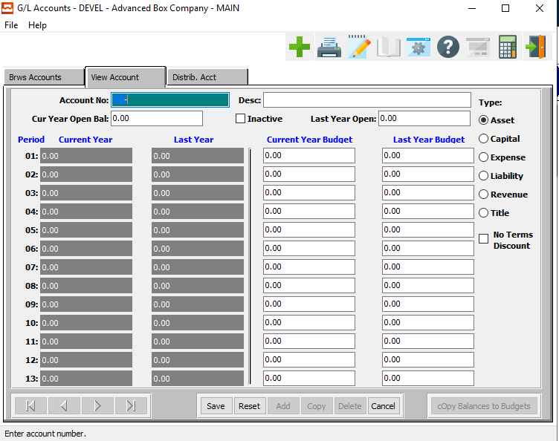

#### SAVE

Click the ***“Save”*** button to save all changes to the current account.

#### RESET

Click the ***“Reset”*** button to reset all fields to their original state.

#### CANCEL

Click the ***“Cancel”*** button to cancel all changes to the account without saving.

### Add/Update Account Field Definitions

#### Account Number

Enter a valid General Ledger account number. To find or change an account press the ***“F1”*** function key to search, or press the ***“Page Up”*** / ***“Page Down”*** keys to scroll through the account numbers.

#### Account Description

In either the ADD or CHANGE mode, enter a description to describe the General Ledger account number.

#### Current Year Open Balance

Enter current year opening balance for the G/L account. Revenue and Expense accounts should always have an opening balance of zero since running year end zeros out the profit and loss accounts.

#### Inactive – Toggle Box

To mark this account as inactive, make sure that the Inactive toggle box is checked.

#### Last Year Open Balance

Enter last year's opening balance for the G/L Account. Running year end will update this field by taking the open balance of the prior year and transferring it to last year open balance.

#### Current Year Budget / Last Year Budget

The first 2 columns of information, Current and 1 Year Ago, represent the next effects of monthly transactions closed to this account (note: that the figure DO NOT represent the account balance at the end of the period, but the net change to the account during the month - debits are positive numbers, credit are negative numbers). The budgets column represents the user defined budgeted

amounts for this account on a monthly basis. The information in the first 2 columns is updated by the system when the MONTH-TO-DATE summary clos function is performed. The figures in the Current or 1 Year Ago columns display either a net Debit or Credit to the Account.

The account history fields are updated when the Month-to-Date summary Report option is completed, and the period is CLOSED. If a closed period is reopened then the history fields remain the same as before the period was reopened, and are updated only when the period is reclosed.

The information in these history fields can be accessed by the user through the "F" (files) option of the G/L main menu, and selecting the General Ledge Accounts program.

#### Type

Enter the account type for the G/L account number.

Valid Account Types are as Follows:

|  |  |  |  |
| --- | --- | --- | --- |
| A | Asset | L | Liability |
| C | Capital | R | Revenue |
| E | Expense | T | Title |

### Distribute Account

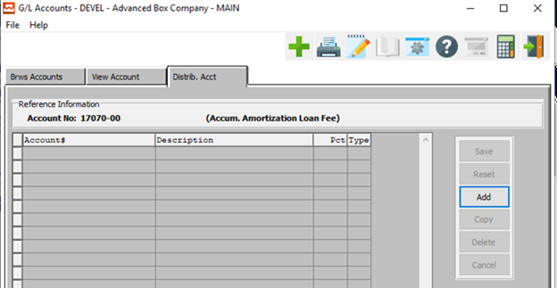

#### ADD

Click the ***“Add”*** button to add a new distribution account.

### Add Distribute Account

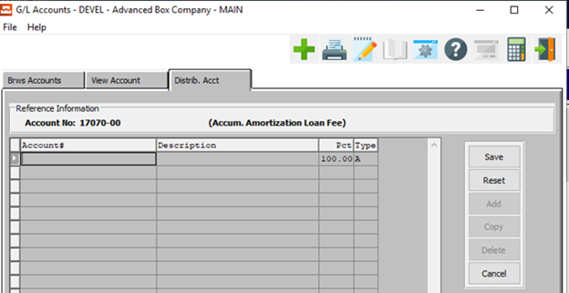

#### SAVE

Click the ***“Save”*** button to save all changes to the current account.

#### RESET

Click the ***“Reset”*** button to reset all fields to their original state.

#### CANCEL

Click the ***“Cancel”*** button to cancel all changes to the account without saving.

### Add Distribute Account Field Definitions

#### Account Number

The user may enter a valid account number. Alternatively, press the ***“F1”*** button to choose a number from a list of available accounts.

#### Description

The description of the account will automatically fill as soon as the user enters or chooses a valid account number.

#### Percent

The percentage will automatically fill as soon as the user enters or chooses a valid account number.

#### Type

The account type will automatically fill as soon as the user enters or chooses a valid account number.

## General Ledger Control [GF3]

The general ledger control file established default numbers for use in the general ledger system. Default account numbers entered will transfer automatically when creating journal entries.

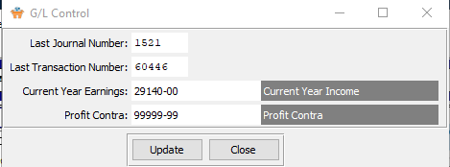

#### UPDATE

To change a General Ledger control file, simply click the ***“Update***” button at the bottom of the screen.

#### CLOSE

Click the ***“Close”*** button to close the Control panel.

### Update General Ledger Control

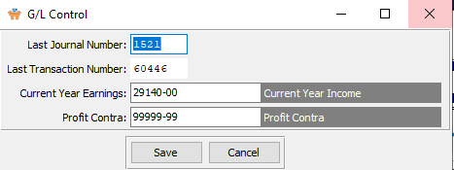

#### SAVE

Click the ***“Save”*** button to save all changes to the current control file.

#### CANCEL

Click the ***“Cancel”*** button to cancel all changes to the control file without saving.

### Update General Ledger Control Field Definitions

#### Last Journal Number

Use the change function if this field needs to be adjusted. This field is updated by the system. The Last Journal Number is the number of the last G/L journal that was created by the Journal Entry/Edit program. This number is incremented when a new G/L journal is created.

#### Last Transaction Number

Use the change function if this field needs to be adjusted. This field is updated by the system. This field is maintained by the system, and is incremented with each posting report that is run throughout the system. You will notice this number at the top of the posting reports. This number also transfers to the month end detail report for audit trail purposes.

#### Current Year Earnings

Enter the retained earnings account number from the General Ledger chart of accounts.

#### Profit Contra

Enter the G/L account number from the chart of account that will be used by the system as the profit contra account. This account number is mandatory and is used during month end and at year end processing.

This account number should be set up as an expense account number. For example: 9999-999-99-9, which would list it last in the chart of accounts. The system stores the net income for each period closed in the history of this account number and transfers this amount to retained earnings at year end.

## Banks [GF4]

### Browse Banks

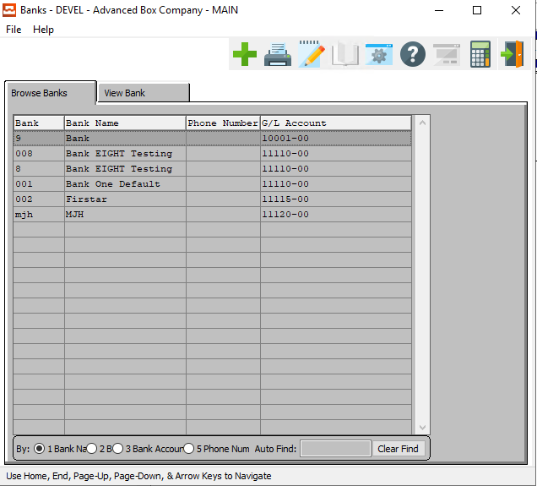

#### ADD

Click the ***“Green + Icon”*** to add a new bank.

### View Bank

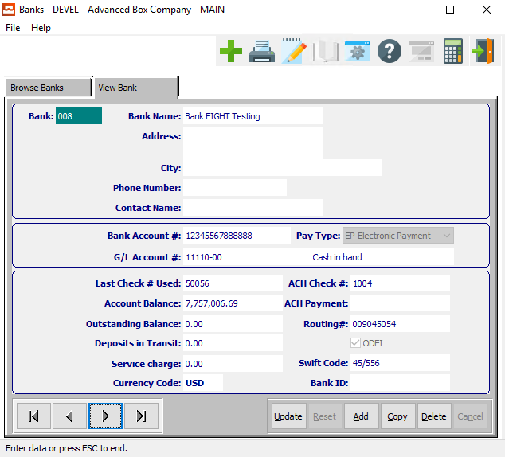

#### ADD

To add a new bank, simply click the ***“Green + Icon”*** button at the top of the Banks screen.

Alternatively, click the ***“Add”*** button at the bottom of the screen.

#### COPY

Click the ***“Copy”*** button to copy information from the currently selected bank.

#### DELETE

To delete a bank, simply press the ***"D"*** key. Alternatively, click the ***“Delete”*** button at the bottom of the screen.

#### NEXT

Press ***"N"*** (Next) to find next bank to view or modify. Alternatively, press the ***“Right Arrow”*** on the screen.

#### PREVIOUS

Press ***"P"*** (Previous) to find previous bank to view or modify. Alternatively, press the ***“Left Arrow”*** on the screen.

### Add Bank

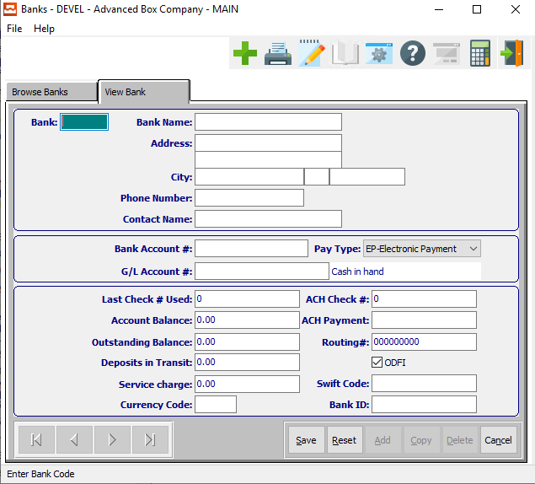

#### SAVE

Click the ***“Save”*** button to save all changes to the current bank.

#### RESET

Click the ***“Reset”*** button to reset all fields to their original state.

#### CANCEL

Click the ***“Cancel”*** button to cancel all changes to the bank without saving.

### Add Bank Field Definitions

#### Bank Code

Enter a unique code to distinguish the bank account. This code will be used by the accounting modules in all cash transactions.

#### Bank Name

Enter the name of the bank.

#### Bank Address

Enter the bank address.

#### Bank City

Enter the city of the branch office of the bank.

#### State

Enter the state of the branch office of the bank.

#### Zip/Postal Code

Enter the zip code of the branch office of the bank.

#### Phone Number

Enter the phone number of the bank. The Phone number may either be the phone number of the branch office, or the main phone number of the bank.

#### Contact Name

Enter the name of the user’s direct contact at the bank.

#### Bank Account Number

Enter the bank account number which applies to the code.

#### General Ledger Account Number

Enter the General Ledger account number from the chart of accounts which is associated with this bank account. Please note, the account number format must be defined in the company file.

#### Pay Type

The user may choose the bank’s Pay Type from a drop-down list of choices.

Valid Choices are as Follows:

|  |  |  |  |
| --- | --- | --- | --- |
| BC | Bitcoin | BD | Direct Business Debit |
| CC | Credit Card | CK | Printed Check |
| DC | Debit Card | DD | Direct Deposit |
| EP | Electronic Payment | ET | Electronic Transfer |
| PA | Payables Advantage | PC | Payment Card |
| VC | Virtual Currency | WT | Wire Transfer |

#### Account Description

The is the name of the account associated with the General Ledger Account number. It is not modifiable here.

#### Last Check # Used

Enter the last used check number. The system defaults to last check number used. The system initializes the field to zero, but the field must be set to the proper check number. This field is used in A/P check printing and may be modified at any time.

#### Account Balance

Enter the Account balance. This field is automatically updated by A/P, A/R, and G/L.

#### Outstanding Balance

Enter the amount of the outstanding checks (that have not cleared the bank according to the bank statement).

Make sure to include all check that have been processed by the system even if they have not been mailed. This field is currently not being updated by the system; it is only updated by manual entry.

#### Routing Number

This is the routing number for the bank account.

#### Deposit in Transit

Enter the amount of the deposits that are not included on the bank statement.

Make sure to include deposits that have been entered into the system even if they have not been deposited. This field is currently not being updated by the system; it is only updated by manual entry.

#### Service Charge

Enter the total amount of the service charges that you are included on the bank statement and have not been entered as journal entries. This field is currently not being updated by the system; it is only updated by manual entry.

#### Currency Code

Enter the currency code our you can use the ***“F1”*** look up to make your selection.

#### Bank ID

The bank ID code.

## Currency Code [GF5]

### Currency Settings Steps

#### Step One

First set up all your currency codes for each country in your general ledger file maintenance menu (***“G” + “F” + ”5”***) as seen below.  All you need is the exchange rate and the account number filled in for your gain/loss for each country code. If you sell to multiple countries, you will have to set a code for each country including your own.

#### Step Two

Set up your company file default currency code in (***“G” + “F” + “1”***) Company file. Your company can be maintained in Canadian dollars, Jamaican dollars, or other. The company file sets your default currency. This currency will be used for all reports.

#### Step Three

Set up each Customer and Vendor with their respective currency code. When the customer or vendor currency does not match the Company Currency, our software uses the exchange rate to calculate the dollars. Set up your customers with the correct currency code in their customer file (***“A” + “F” + “1”***)

#### Step Four

Set up your Vendors with the correct currency code in their vendor file (***“V” + “F” + “1”***) Posting an AR invoice makes adjusting entry to the gain/loss account automatically. It will make this adjustment for Payable invoice, cash receipts and also AP checks.

### Browse Currency

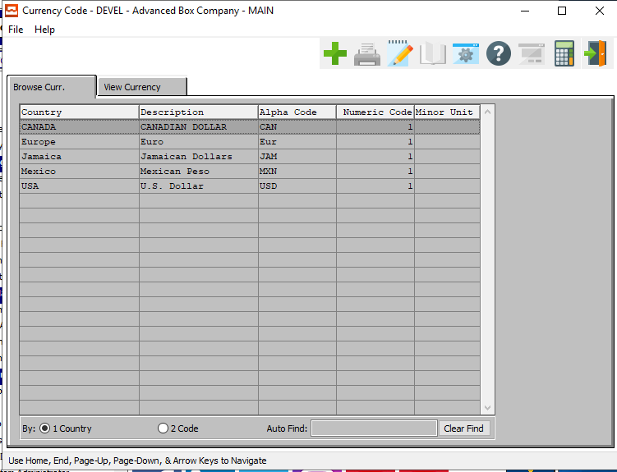

#### ADD

Click the ***“Green + Icon”*** to add a new currency.

### View Currency

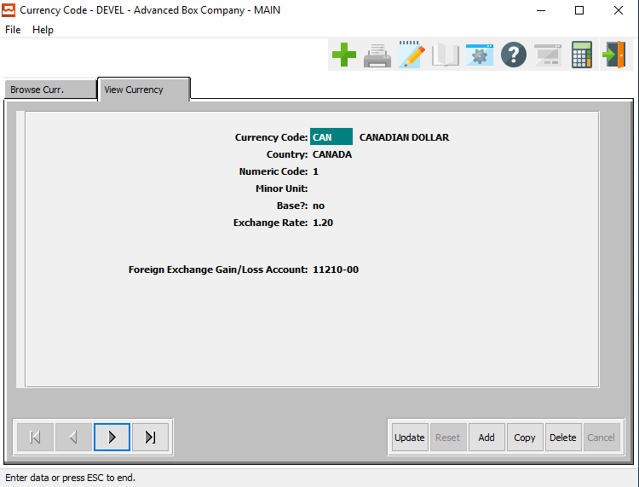

#### UPDATE

To change a currency’s information, simply click the ***“Update***” button at the bottom of the screen.

#### ADD

To add a new currency, simply click the ***“Green + Icon”*** button at the top of the Currency Code screen.

Alternatively, click the ***“Add”*** button at the bottom of the screen.

#### COPY

Click the ***“Copy”*** button to copy information from the currently selected currency.

#### DELETE

To delete an currency, simply press the ***"D"*** key. Alternatively, click the ***“Delete”*** button at the bottom of the screen.

#### NEXT

Press ***"N"*** (Next) to find next currency to view or modify. Alternatively, press the ***“Right Arrow”*** on the screen.

#### PREVIOUS

Press ***"P"*** (Previous) to find previous currency to view or modify. Alternatively, press the ***“Left Arrow”*** on the screen.

### Add/Update Currency

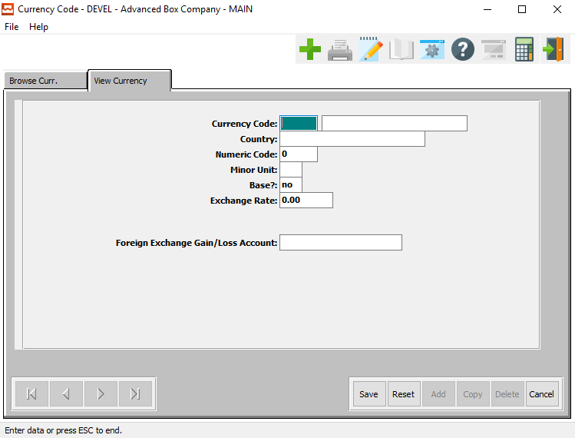

#### SAVE

Click the ***“Save”*** button to save all changes to the current currency.

#### RESET

Click the ***“Reset”*** button to reset all fields to their original state.

#### CANCEL

Click the ***“Cancel”*** button to cancel all changes to the currency without saving.

### Add/Update Currency Field Definitions

#### Currency Code

Enter the currency code or you may look up the currency code by using the ***“F1”*** Key.

#### Currency Name

Enter the currency code name in this field.

#### Country

Enter the country code.

#### Numeric Code

Enter the numeric code.

#### Minor Unit

Enter the minor unit.

#### Base?

Enter either ***“Yes”*** or ***“No”*** to indicate if this is the base currency.

#### Exchange Rate

Enter the exchange rate of the currency.

#### Foreign Exchange Gain/Loss Amount

Enter account number or use the ***“F1”*** key for the look-up menu.

## Import GL Accounts Budgets [GF6]

To import the figures into Advanced Software, you will go to the GF6 menu option and type in the location of the file. See below.  When finished processing, the budgets will then be filled into the current year budget column in the account file.

### Selection Parameters

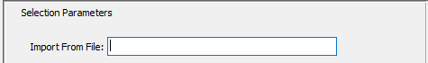

#### Import From File

Enter the import file name in this field. Alternatively, press ***“F1”*** to look-up drive letter and location of file.